Process Mining and Intelligence Project  
Emotion Based Music Selection

Ettore Ricci

Francesco Boldrini

Paolo Palumbo

Zahra Omrani

# BPMN modeling

## Process landscape

[*Ettore Ricci, Paolo Palumbo, Francesco Boldrini, Zahra Omrani*]

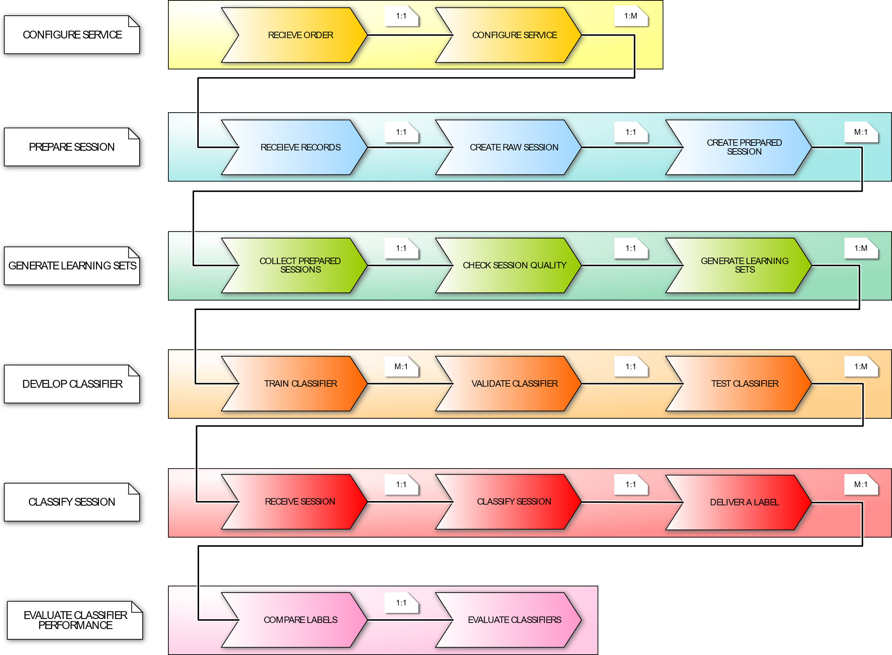

Process landscape

## Process model

### Prepare session

[*Ettore Ricci, Paolo Palumbo*]

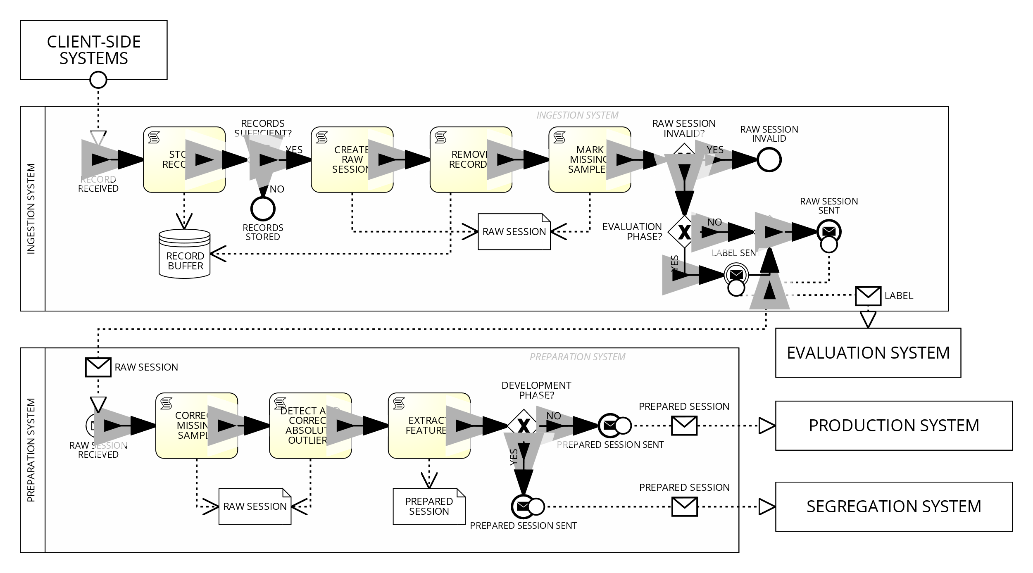

Business Diagram of the "Prepare session" process

### Generate learning sets

[*Ettore Ricci, Paolo Palumbo*]

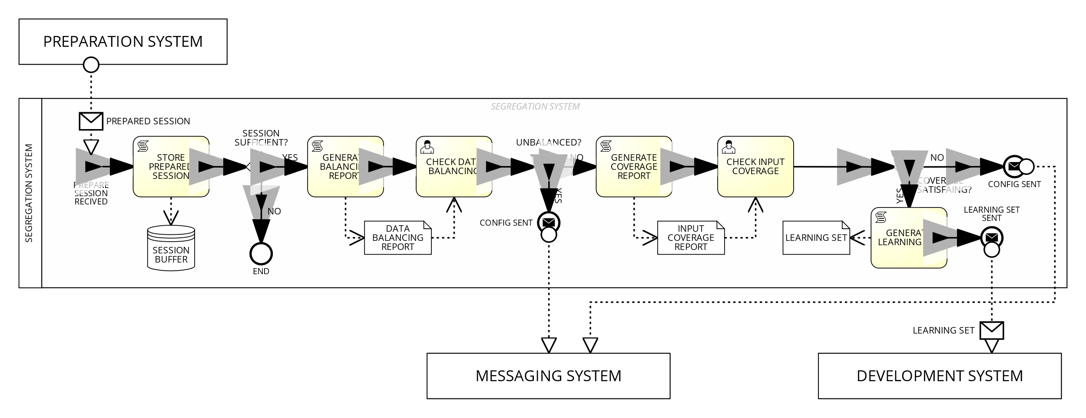

Business Diagram of the "Generate learning sets" process

### Develop classifier

[*Ettore Ricci, Paolo Palumbo*]

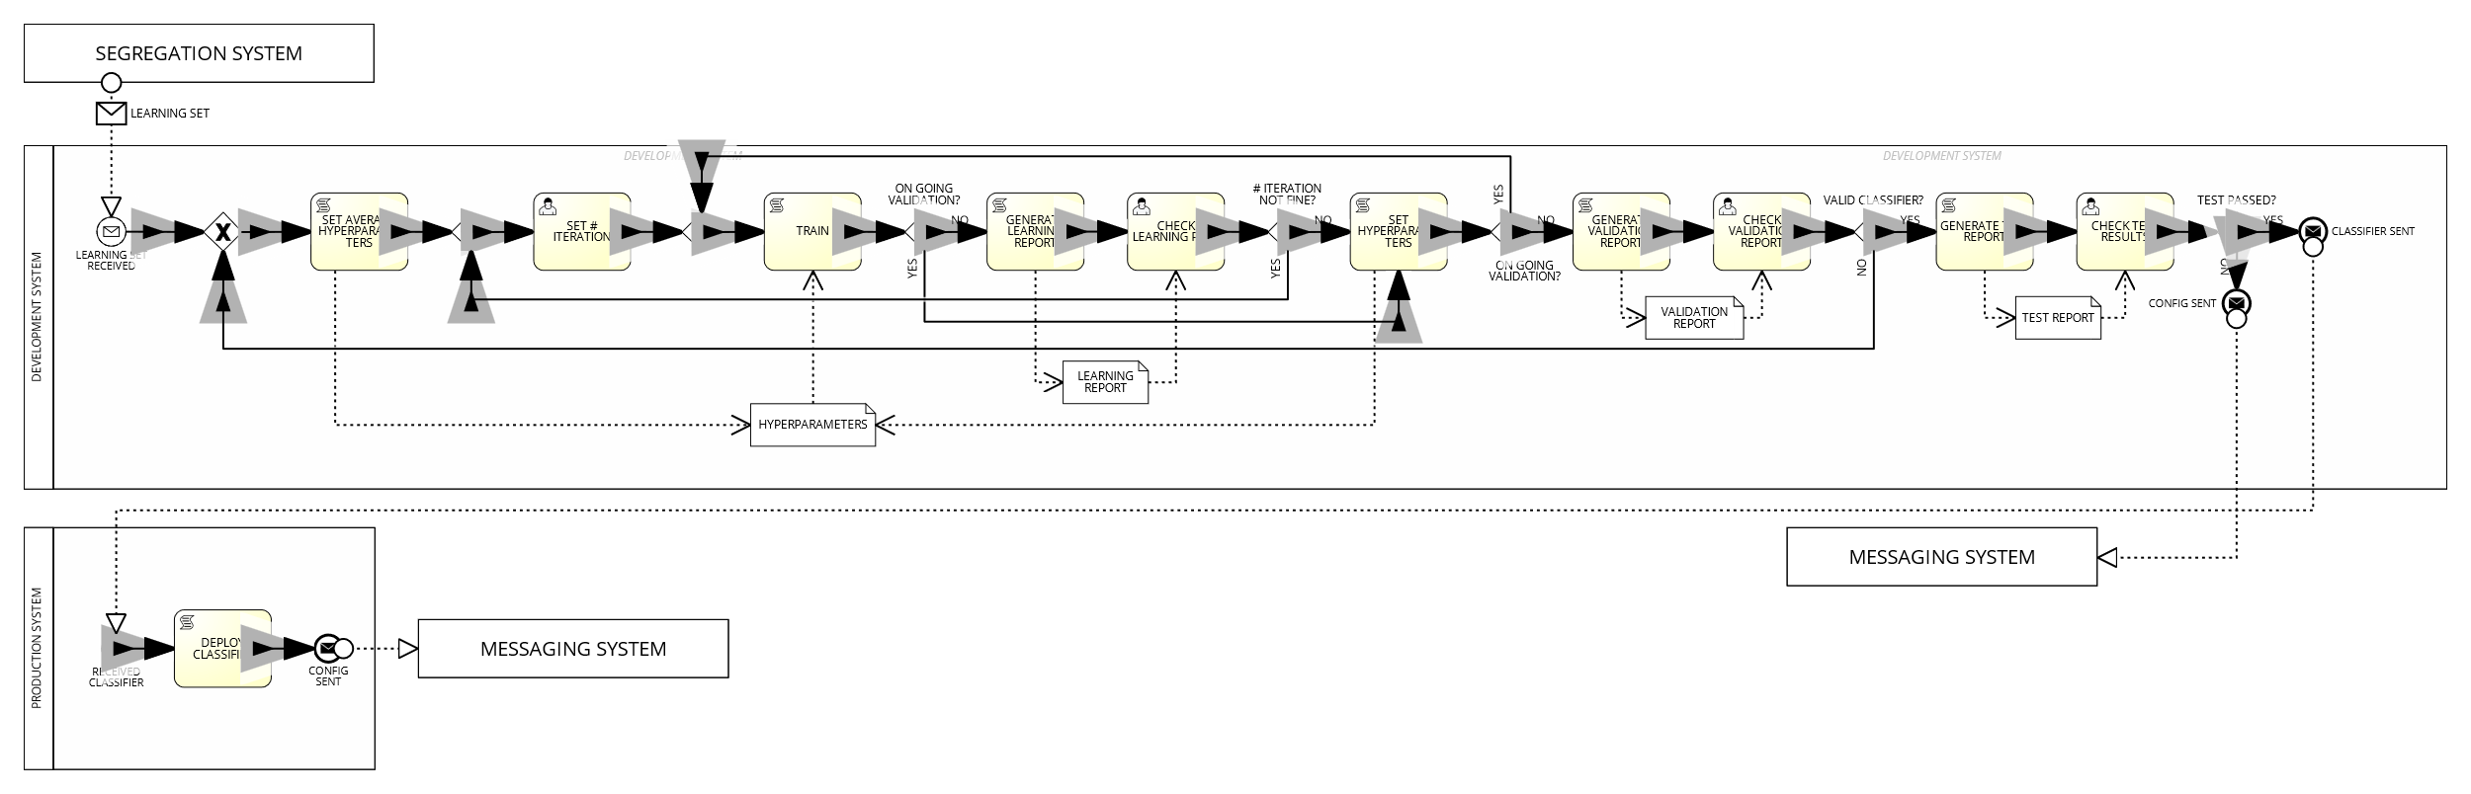

Business Diagram of the "Develop classifier" process

### Classify session

[*Ettore Ricci, Paolo Palumbo*]

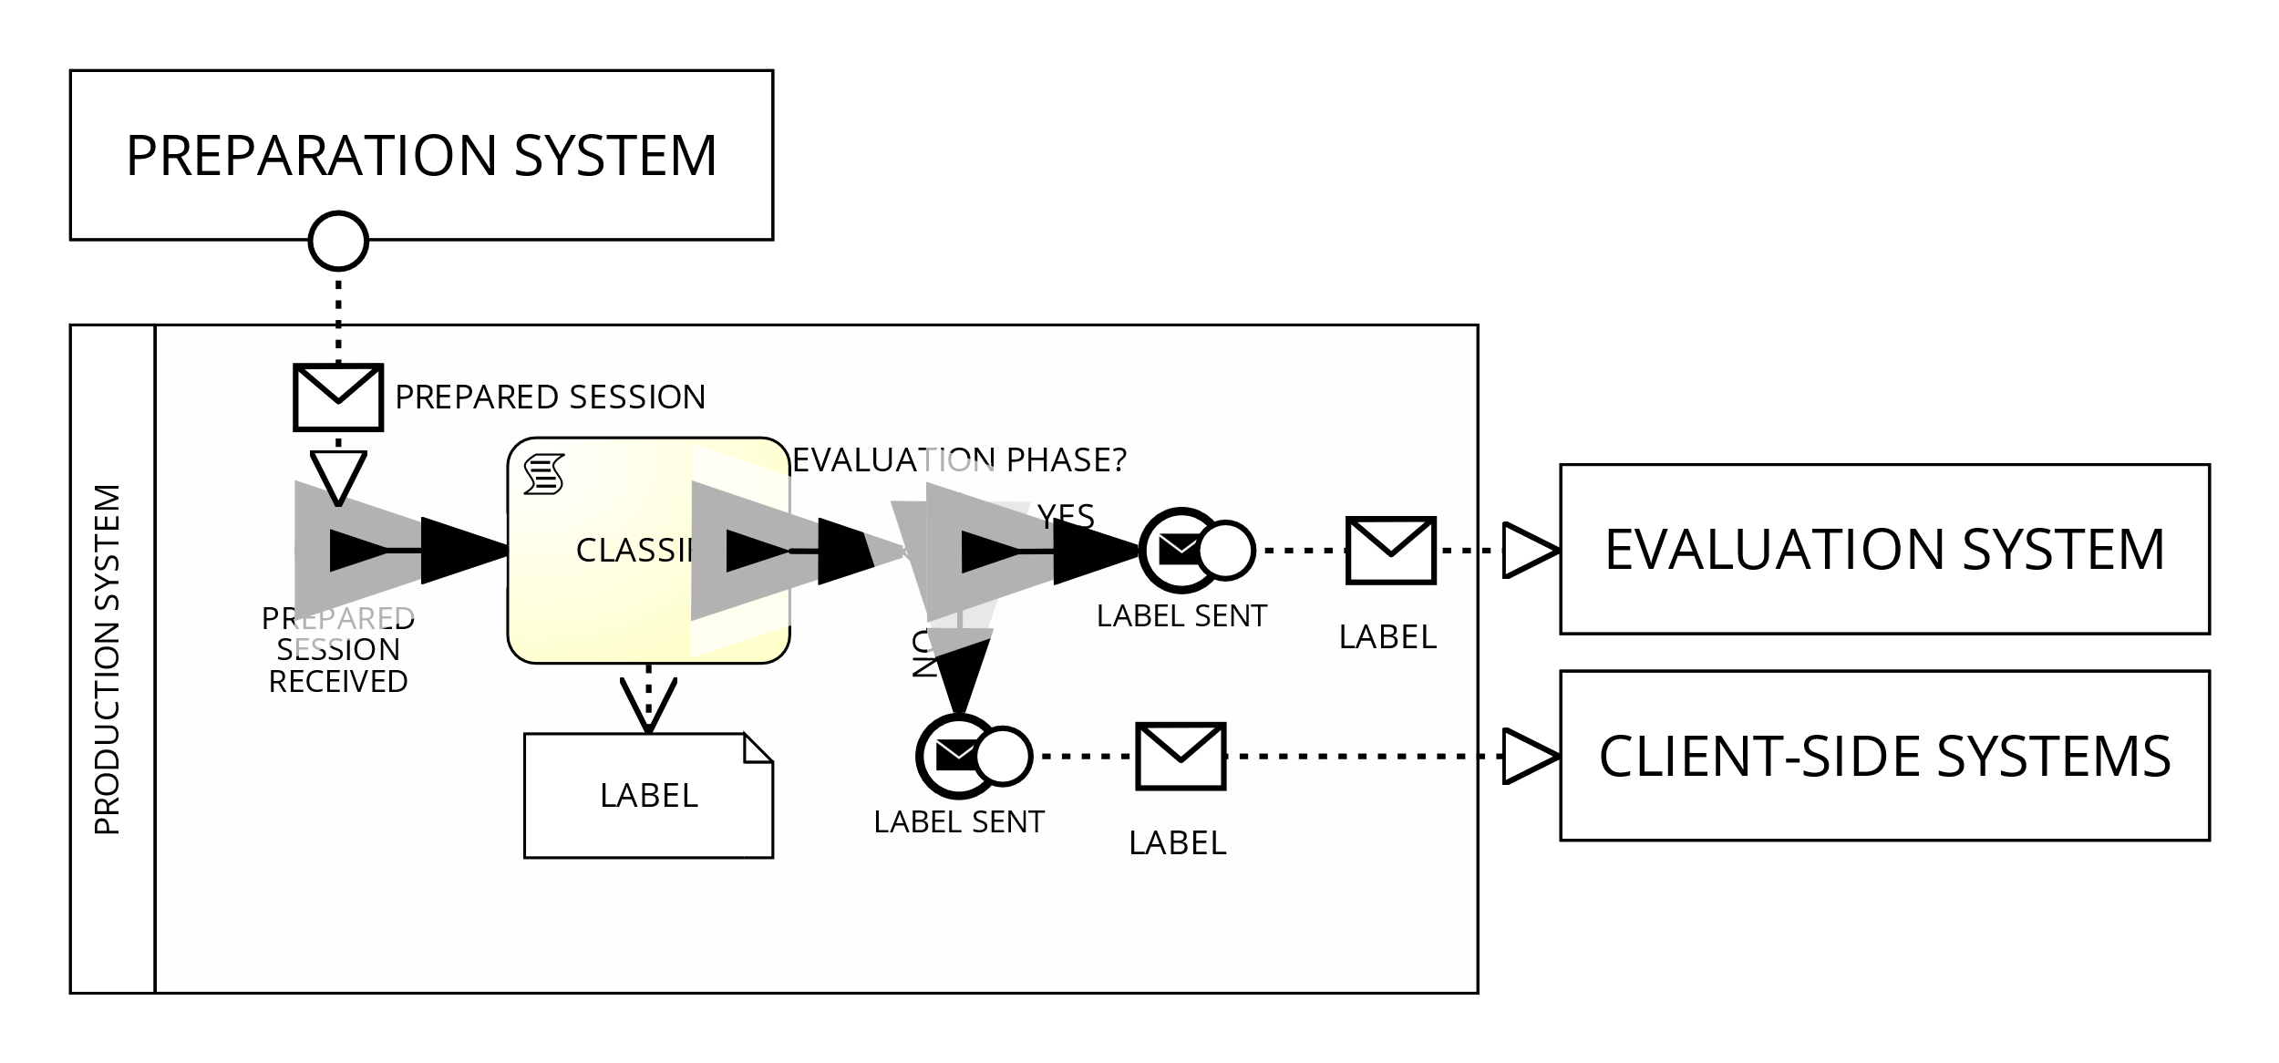

Business Diagram of the "Classify session" process

### Evaluate classifier performance

[*Ettore Ricci, Paolo Palumbo*]

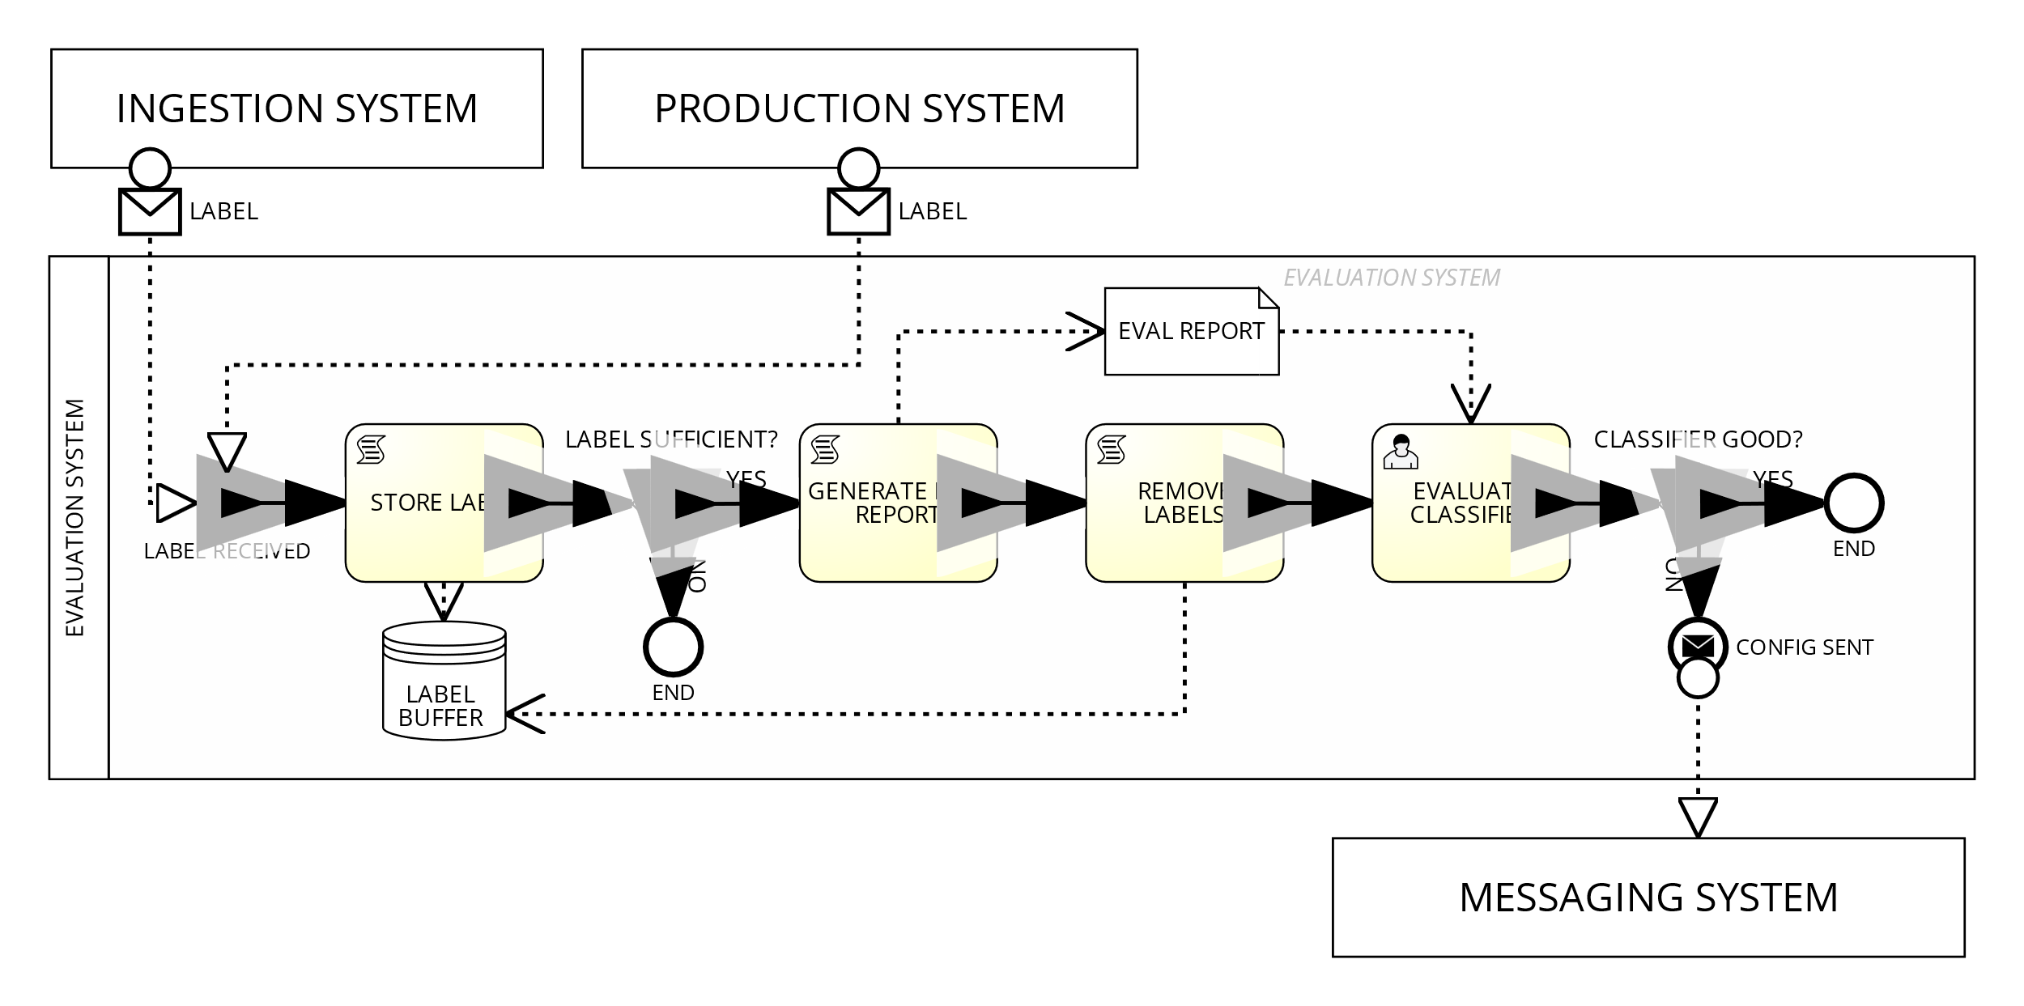

Business Diagram of the "Evaluate classifier performance" process

### 

### Configure systems

[*Ettore Ricci, Paolo Palumbo*]

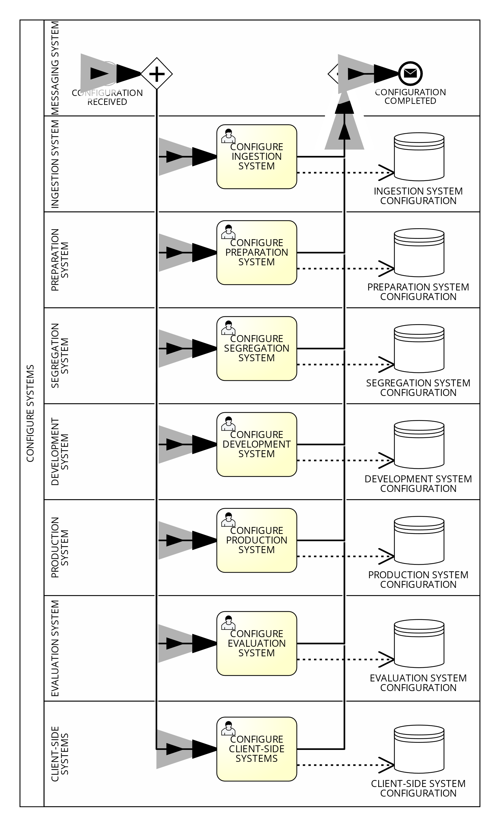

Business Diagram of the "Configure systems" process

# Data modeling

## Process model

### Prepare session

[*Ettore Ricci*]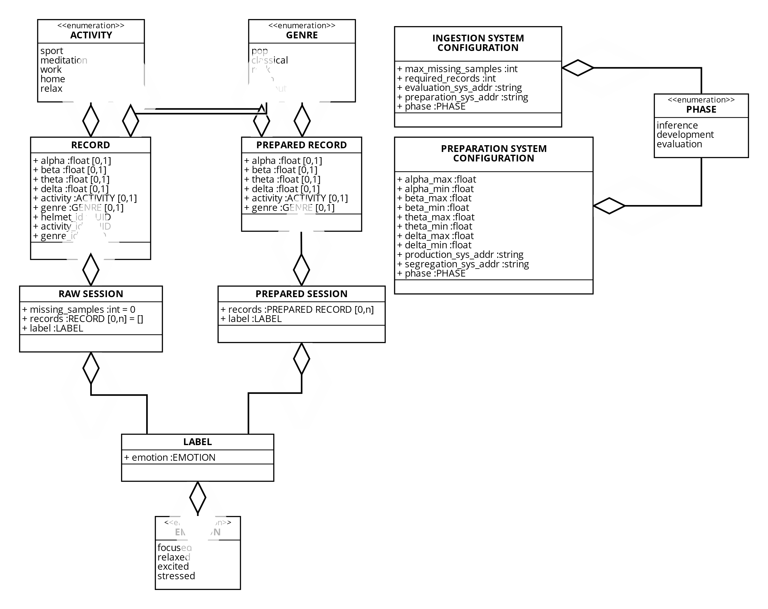

Data Model of the "Prepare session" process

### Generate learning sets

[*Paolo Palumbo*]

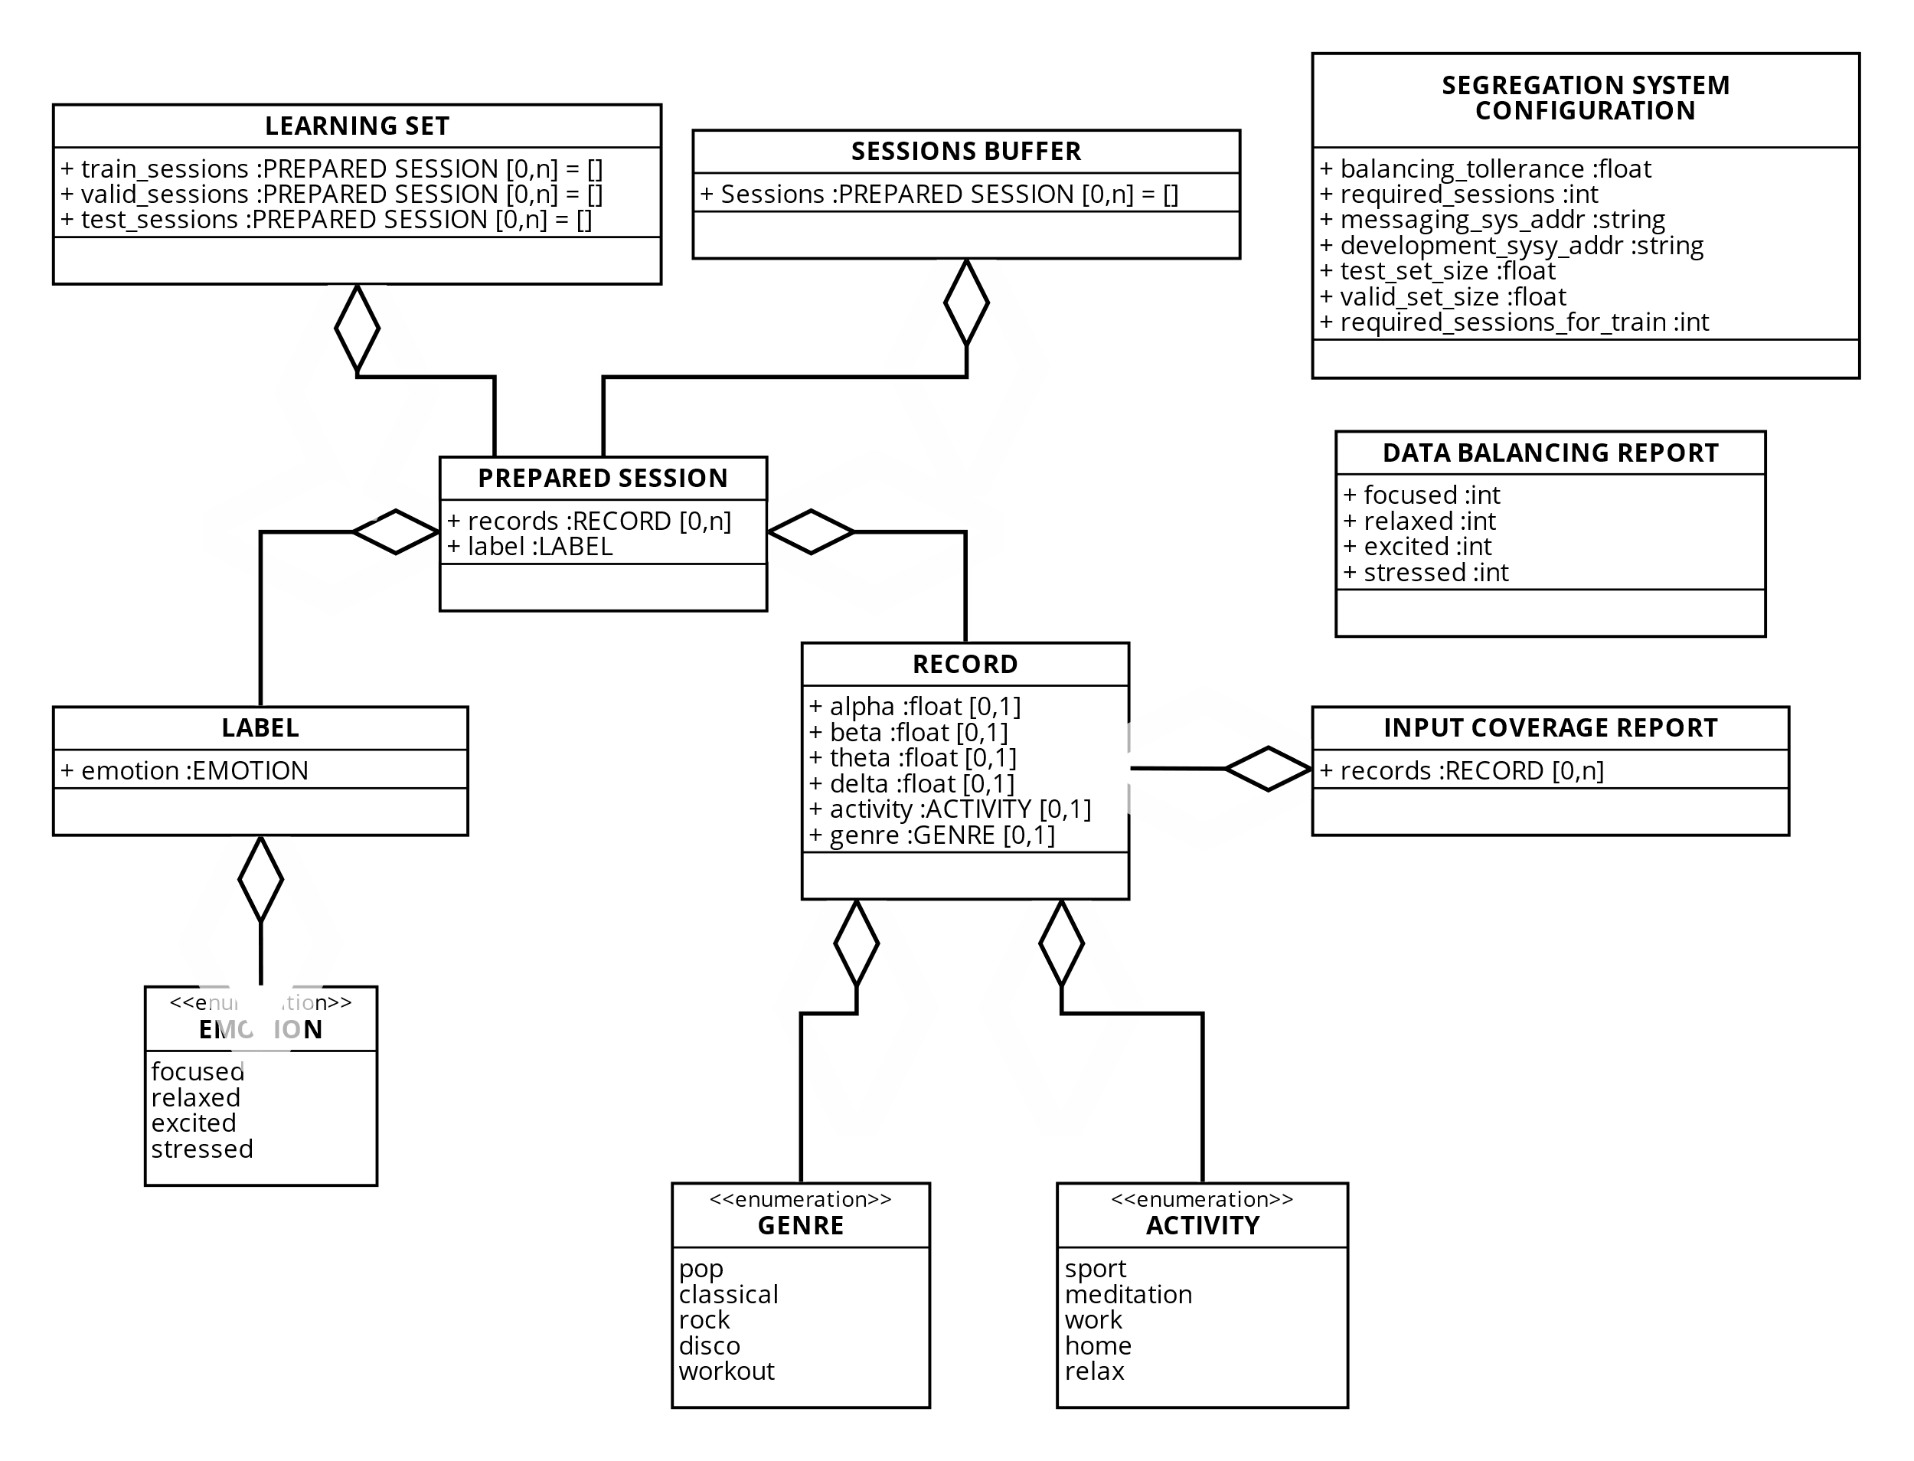

Data Model of the "Generate learning sets" process

### Develop classifier

[*Paolo Palumbo*]

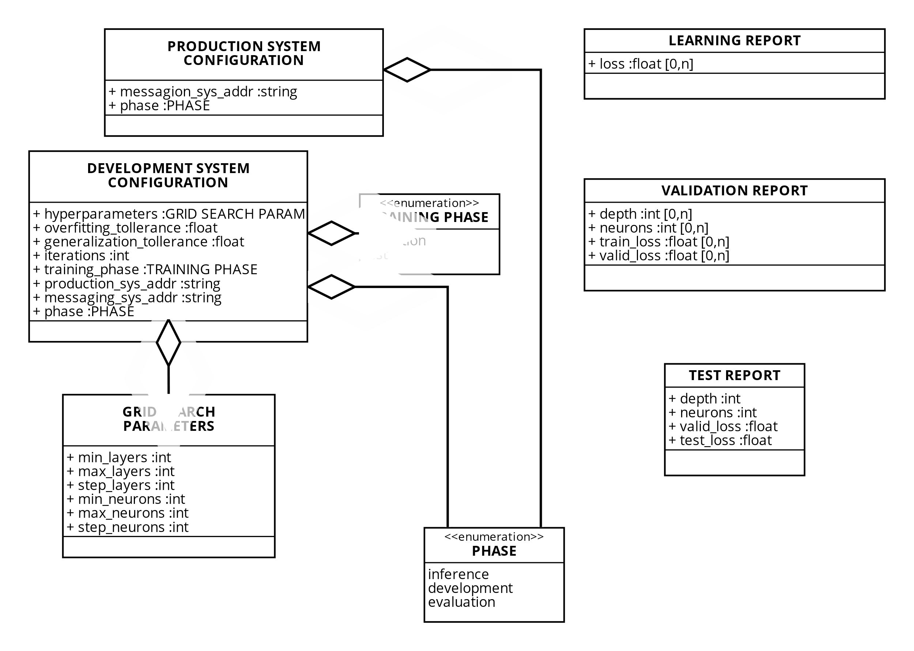

Data Model of the "Develop classifier" process

### Classify session

[*Francesco Boldrini*]

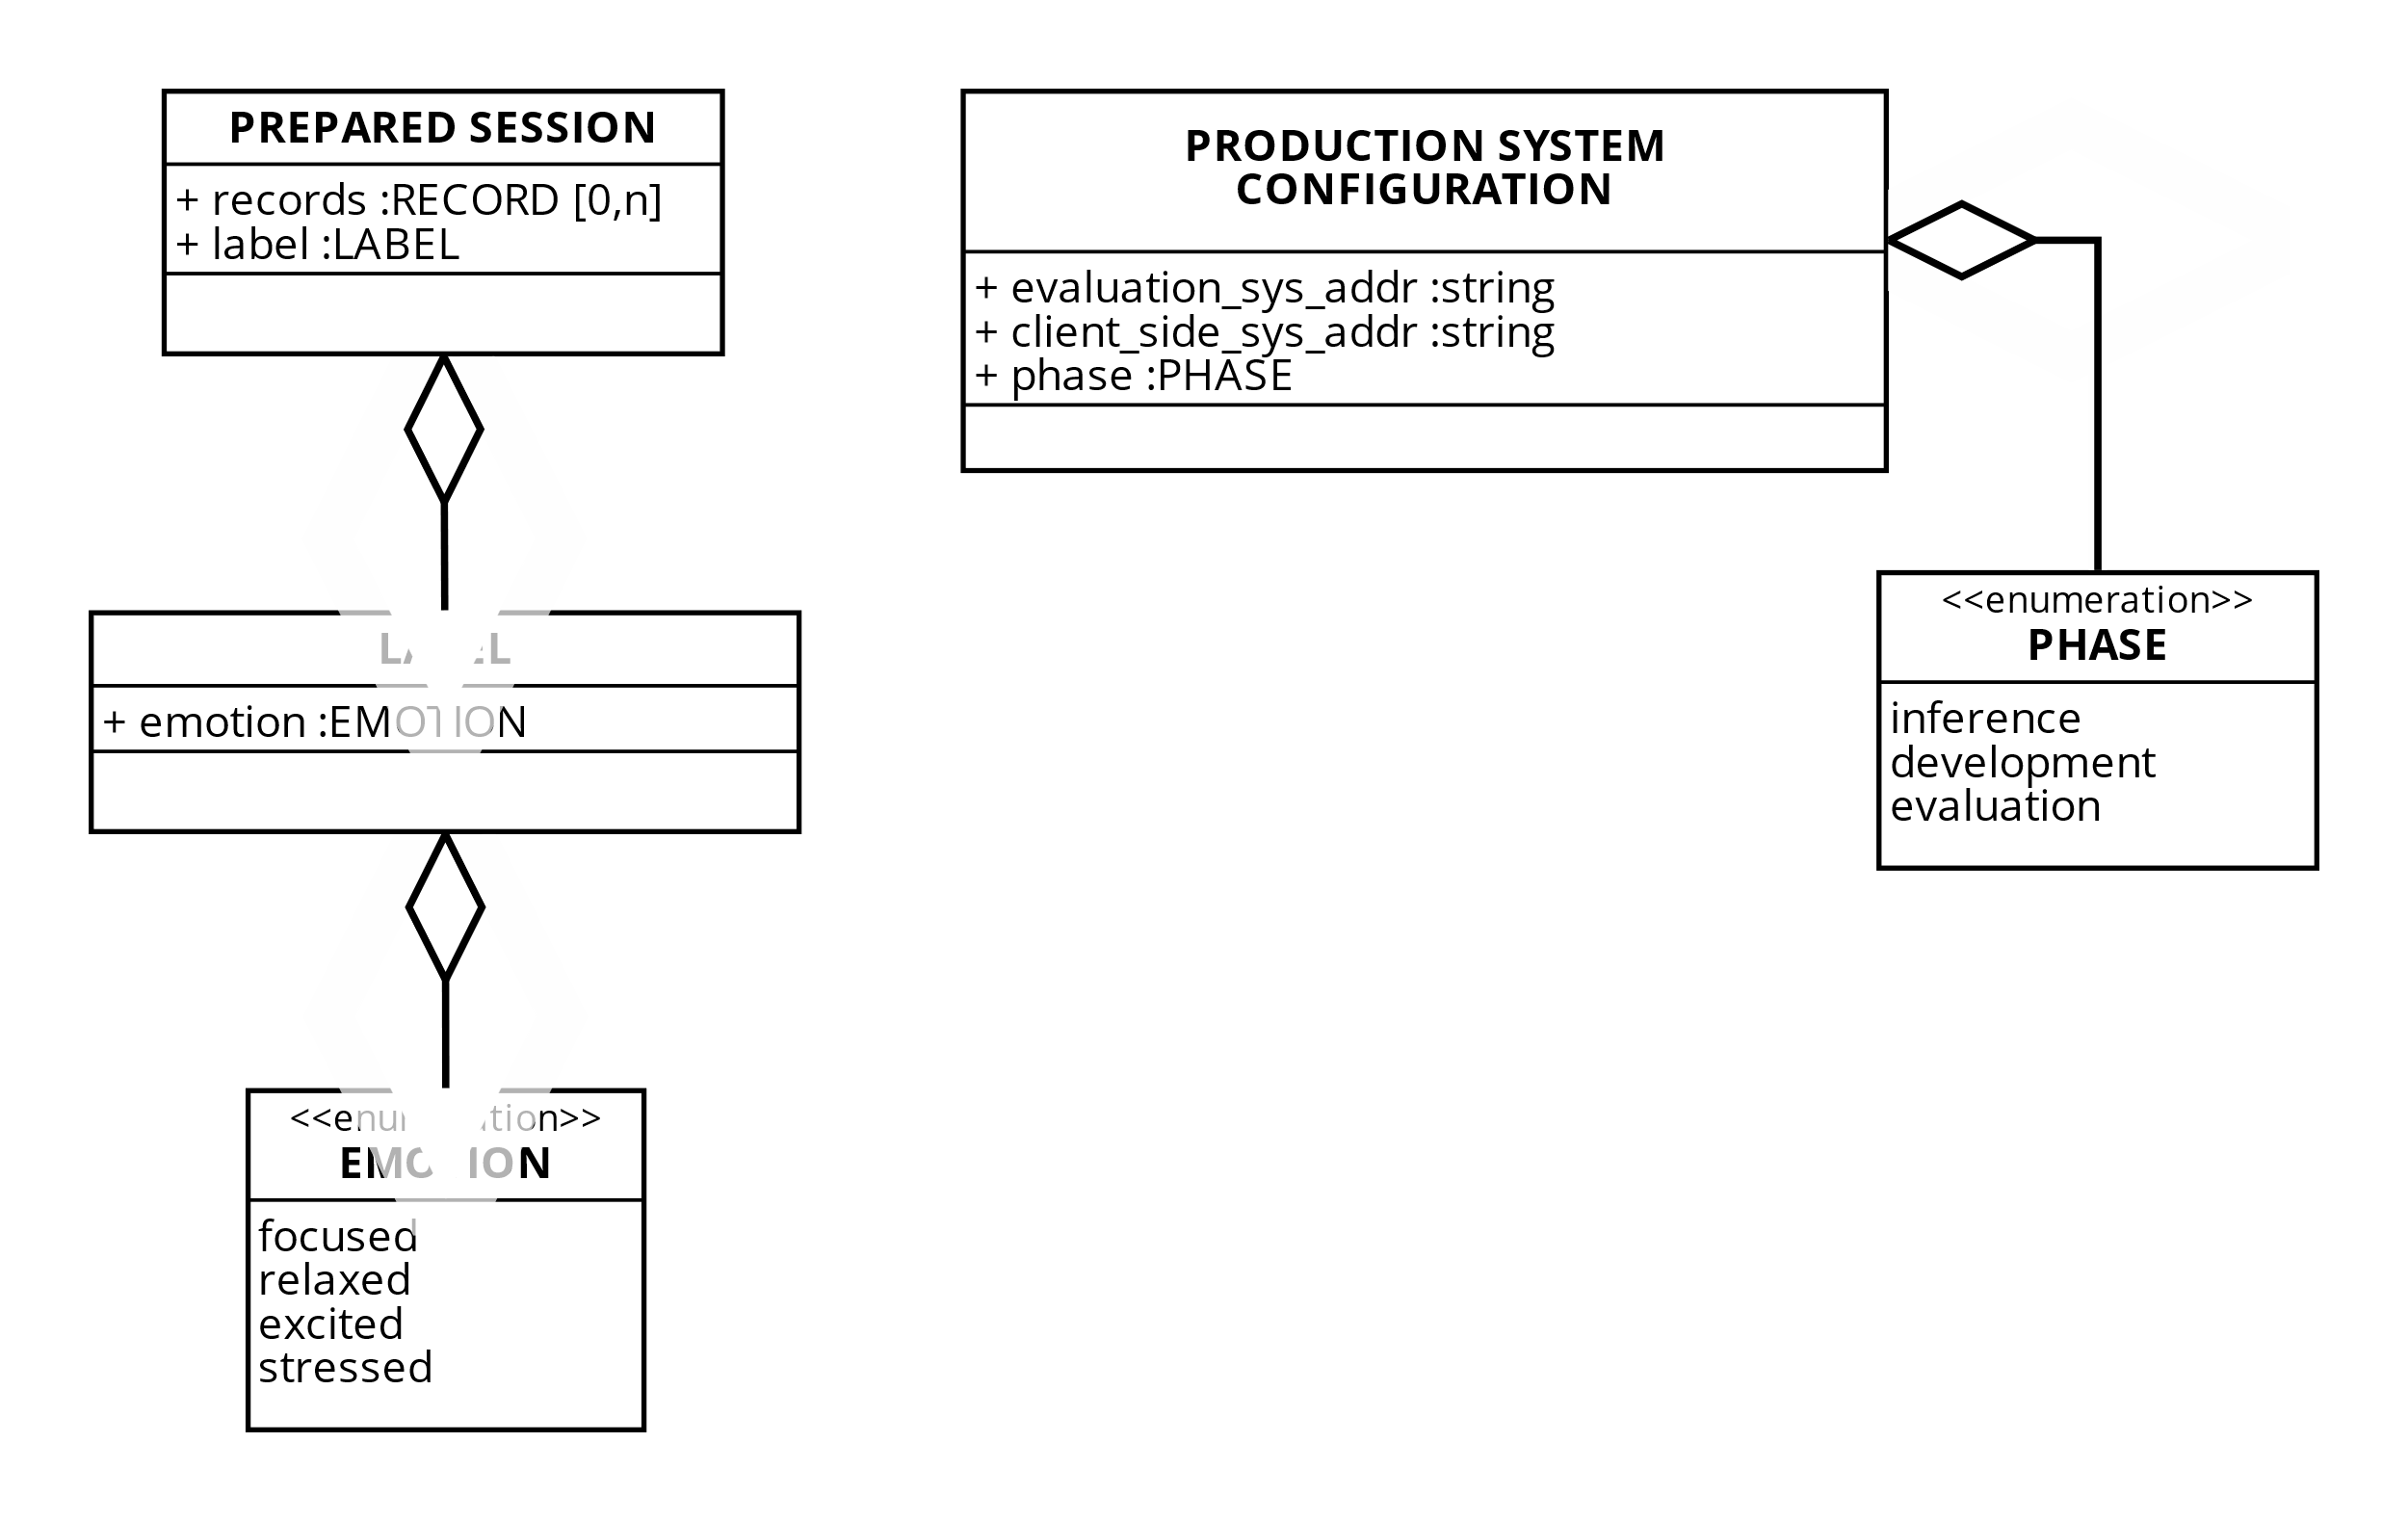

Data Model of the "Classify session" process

### Evaluate classifier performance

[*Zahra Omrani*]

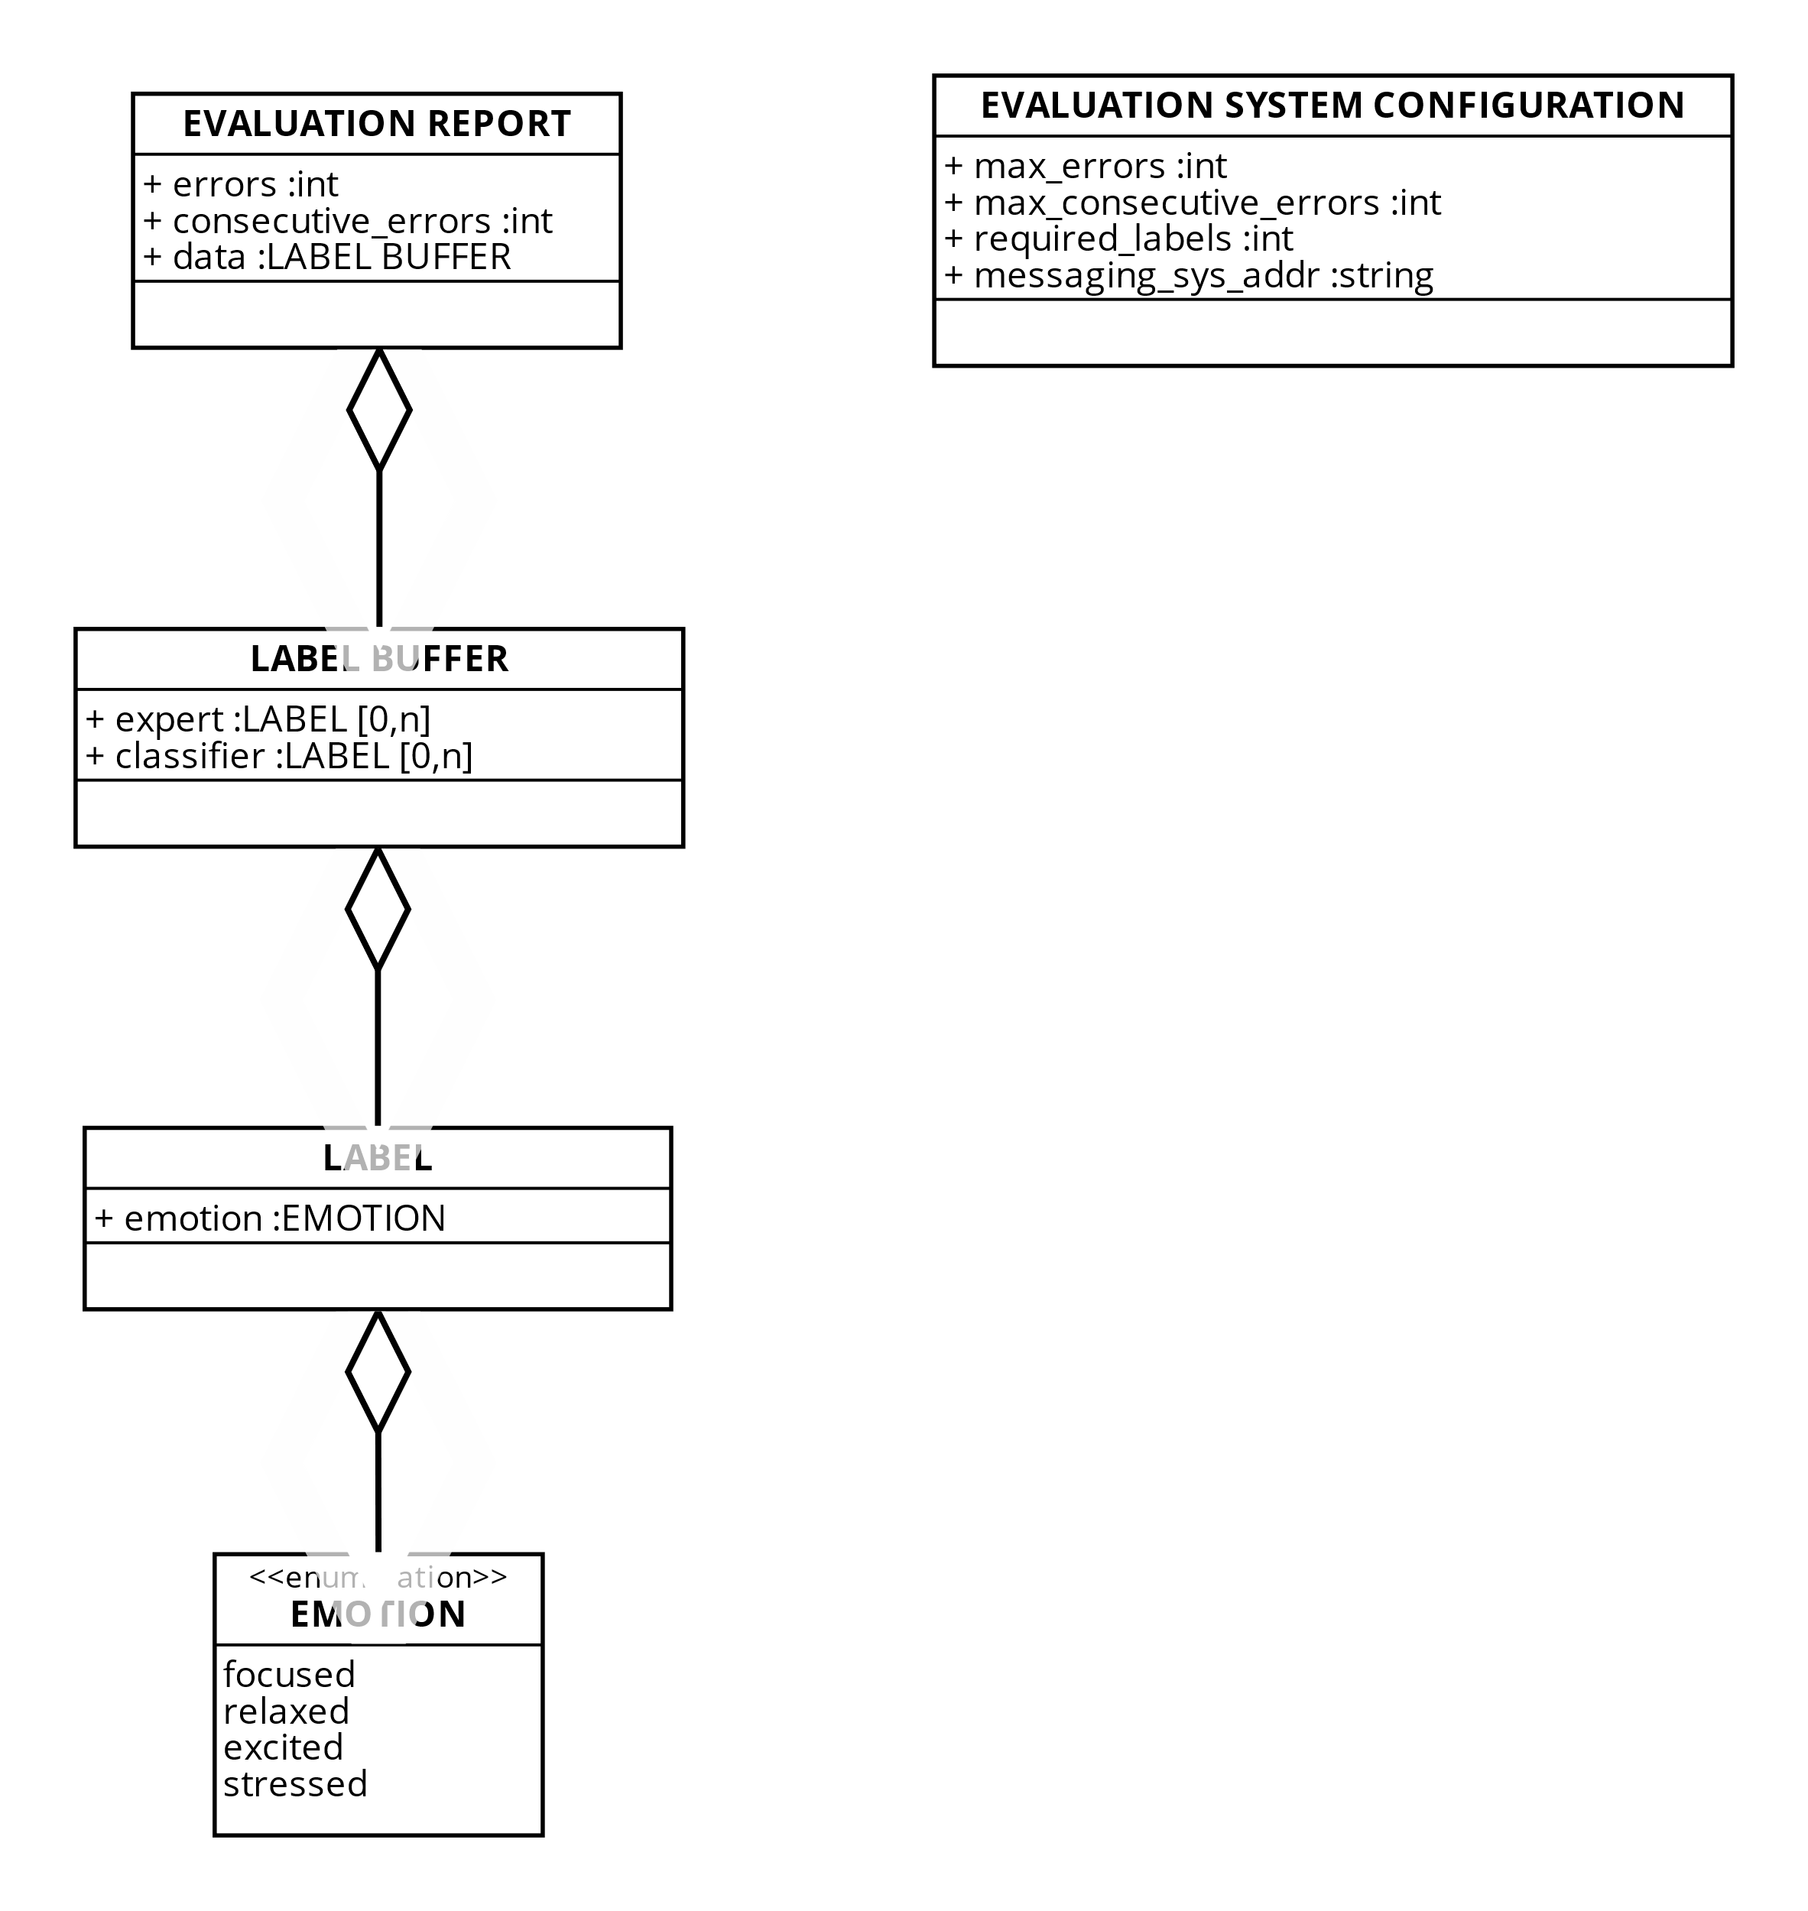

Data Model of the "Evaluate classifier performance" process

# Task level modeling

## Roles and salaries

[*Ettore Ricci, Paolo Palumbo*]

Salary and normalized salary for each position

| **Position** | **Description** | **Salary** | **Normalized Salary** |
| --- | --- | --- | --- |
| Clerk | Handles administrative tasks, organizes documentation, and assists with data entry and labeling. Ensures smooth operations by coordinating communication and managing resources. | $52,000.00 | 1.00 |
| Data analyst | Prepares, analyzes, and visualizes data to extract insights. Collaborates on cleaning datasets, identifying trends, and supporting model validation. | $60,000.00 | 1.15 |
| ML engineer | Builds, tests, and deploys machine learning models, optimizing performance and scalability. Integrates AI solutions into production systems with a focus on efficiency. | $130,000.00 | 2.50 |
| Data scientist | Designs and experiments with AI models, applying advanced techniques to solve project challenges. Collaborates with experts to integrate domain knowledge and refine outputs. | $123,000.00 | 2.37 |
| Domain expert (Neurologist) | Provides medical expertise to guide AI development and validate results. Ensures solutions align with clinical standards and address neurological challenges. | $267,000.00 | 5.13 |
| **Minimum** | | $52,000.00 | 1.00 |

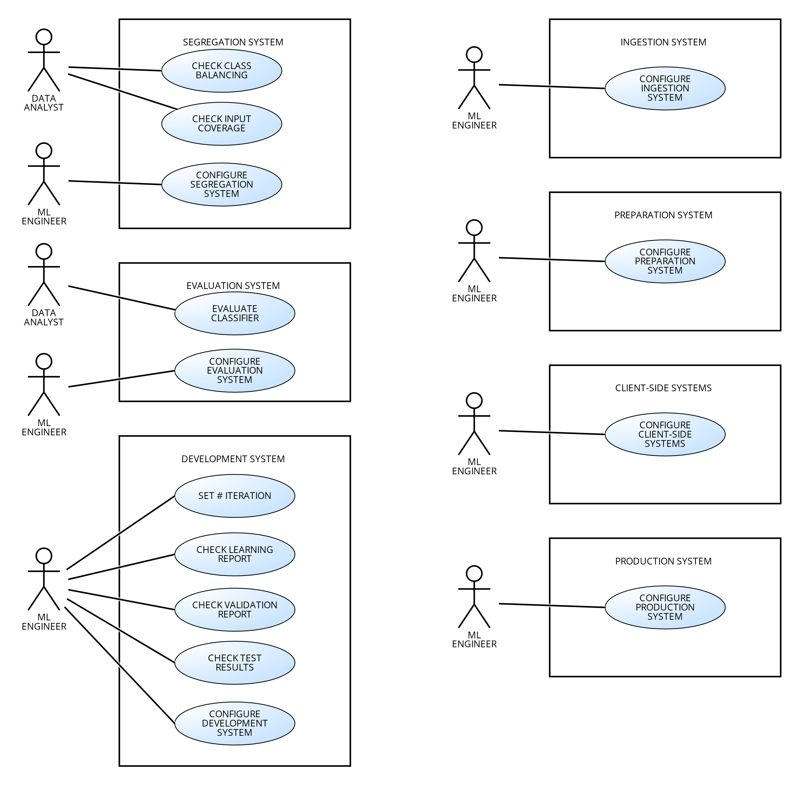

Use case diagram

## Segregation system

### Check data balancing

[*Ettore Ricci, Paolo Palumbo*]

The task is performed by a Data Analyst.

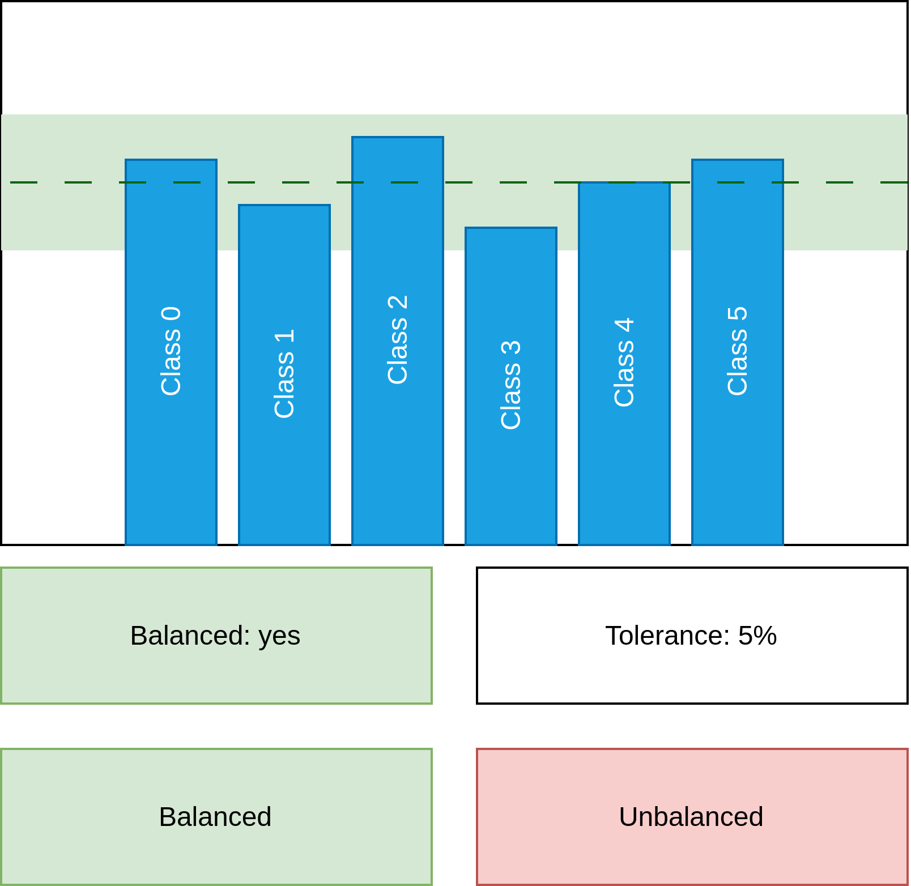

"Check data balancing" mock-up form

Detailed use case for "Check data balancing" task  
O - Occurrence, CL - Cognitive Level, S - Normalized Salary, SC - Step Cost

| **Step** | **O** | **CL** | **S** | **SC** |
| --- | --- | --- | --- | --- |
| **1** **ACTOR** opens "Check data balancing" form. | 1 | 1 | 1.15 | 1.15 |
| **2** **SYSTEM** shows the report. |  |  |  |  |
| **3** **SYSTEM** shows a hint whether the data is balanced or not. |  |  |  |  |
| **4** **ACTOR** checks the hint to see if the data is balanced or not. | 1 | 2 | 1.15 | 2.30 |
| **5.1** **IF** the data is balanced. | 0.2 |  |  |  |
| **5.1.1** **ACTOR** clicks "Balanced" button. | 0.2 | 1 | 1.15 | 0.23 |
| **5.2** **ELSE** | 0.8 |  |  |  |
| **5.2.1** **ACTOR** clicks "Unbalanced" button. | 0.8 | 1 | 1.15 | 0.92 |
| **7** **SYSTEM** shows a confirmation dialog. |  |  |  |  |
| **8** **ACTOR** closes the form. | 1 | 1 | 1.15 | 1.15 |
| Human task cost | | | | 5.74 |

### 

### Check input coverage

[*Ettore Ricci, Paolo Palumbo*]

The task is performed by a Data Analyst.

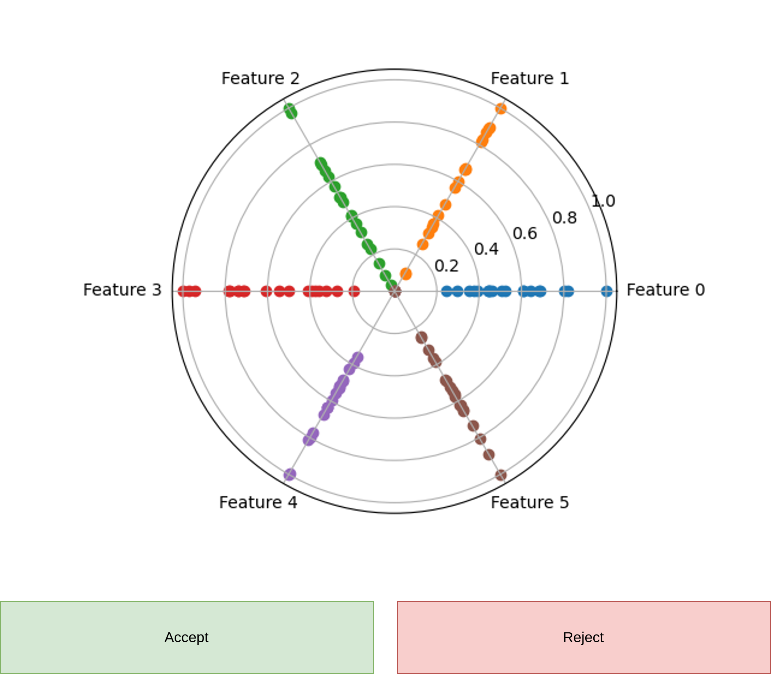

"Check input coverage" mock-up form

Detailed use case for "Check input coverage" task  
O - Occurrence, CL - Cognitive Level, S - Normalized Salary, SC - Step Cost

| **Step** | **O** | **CL** | **S** | **SC** |
| --- | --- | --- | --- | --- |
| **1** **ACTOR** opens "Check input coverage" form. | 1 | 1 | 1.15 | 1.15 |
| **2** **SYSTEM** shows a radar scatter plot of the input distribution. |  |  |  |  |
| **3** **FOR EACH** radius in the radar scatter plot: | 6 |  |  |  |
| **3.1** **ACTOR** checks if the distribution is uniform on the radius. | 6 | 4 | 1.15 | 27.6 |
| **3.1.1** **IF** the distribution is not uniform as expected. | 4 |  |  |  |
| **3.1.1.1** **THEN** the input coverage is not satisfied. | 4 |  |  |  |
| **4.1** **IF** the input coverage is satisfied. | 0.33 |  |  |  |
| **4.1.1** **ACTOR** clicks "Accept" button. | 0.33 | 1 | 1.15 | 0.38 |
| **4.2** **ELSE** | 0.66 |  |  |  |
| **4.2.1** **ACTOR** clicks "Reject" button. | 0.66 | 1 | 1.15 | 0.76 |
| **5** **SYSTEM** shows a confirmation dialog. |  |  |  |  |
| **6** **ACTOR** closes the form. | 1 | 1 | 1.15 | 1.15 |
| Human task cost | | | | 31.04 |

### Configure Segregation System

[*Francesco Boldrini, Zahra Omrani*]

This task is performed by a ML Engineer.

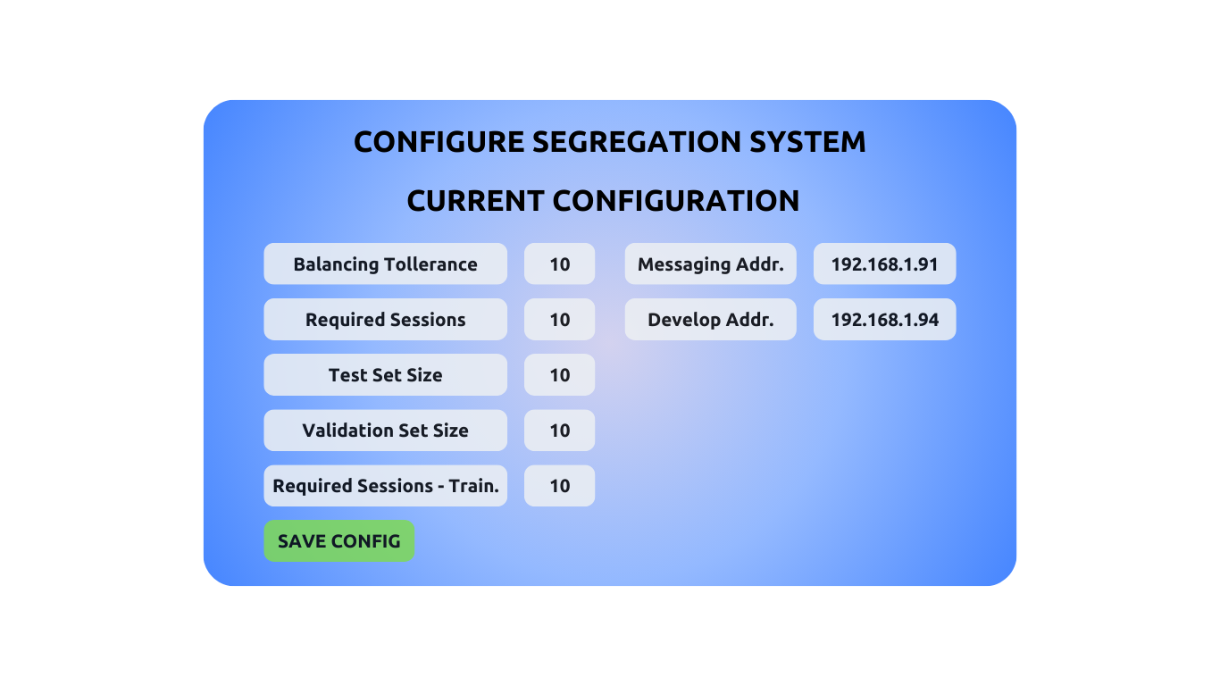

"Configure Segregation System" mock-up form

Detailed use case for "Configure Segregation System" task  
O - Occurrence, CL - Cognitive Level, S - Normalized Salary, SC - Step Cost

| **Step** | **O** | **CL** | **S** | **SC** |
| --- | --- | --- | --- | --- |
| **1** **ACTOR** opens the "Configure Segregation System" form. | 1 | 1 | 2.50 | 2.50 |
| **2** **SYSTEM** displays the current configuration. |  |  |  |  |
| **3** **ACTOR** sets the balancing_tolerance. | 1 | 4 | 2.50 | 10 |
| **4** **ACTOR** sets the required_sessions. | 1 | 4 | 2.50 | 10 |
| **5** **ACTOR** sets the messaging_sys_addr. | 1 | 1 | 2.50 | 2.50 |
| **6** **ACTOR** sets the development_sys_addr. | 1 | 1 | 2.50 | 2.50 |
| **7** **ACTOR** sets the test_set_size. | 1 | 4 | 2.50 | 10 |
| **8** **ACTOR** sets the valid_set_size. | 1 | 4 | 2.50 | 10 |
| **9** **ACTOR** sets the required_sessions_for_train. | 1 | 4 | 2.50 | 10 |
| **10** **SYSTEM** validates the configuration. |  |  |  |  |
| **10.1** **IF** the configuration is correct and properly formatted: |  |  |  |  |
| **10.1.1** **SYSTEM** displays a confirmation message. |  |  |  |  |
| **10.2** **ELSE** (if the configuration is incorrect): |  |  |  |  |
| **10.2.1** **SYSTEM** displays an error message and aborts the process. |  |  |  |  |
| **11** **ACTOR** saves the form. | 1 | 1 | 2.50 | 2.50 |
| Human task cost | | | | 60 |

## Development system

### Set iteration number

[*Zahra Omrani*]

The task is performed by a ML engineer.

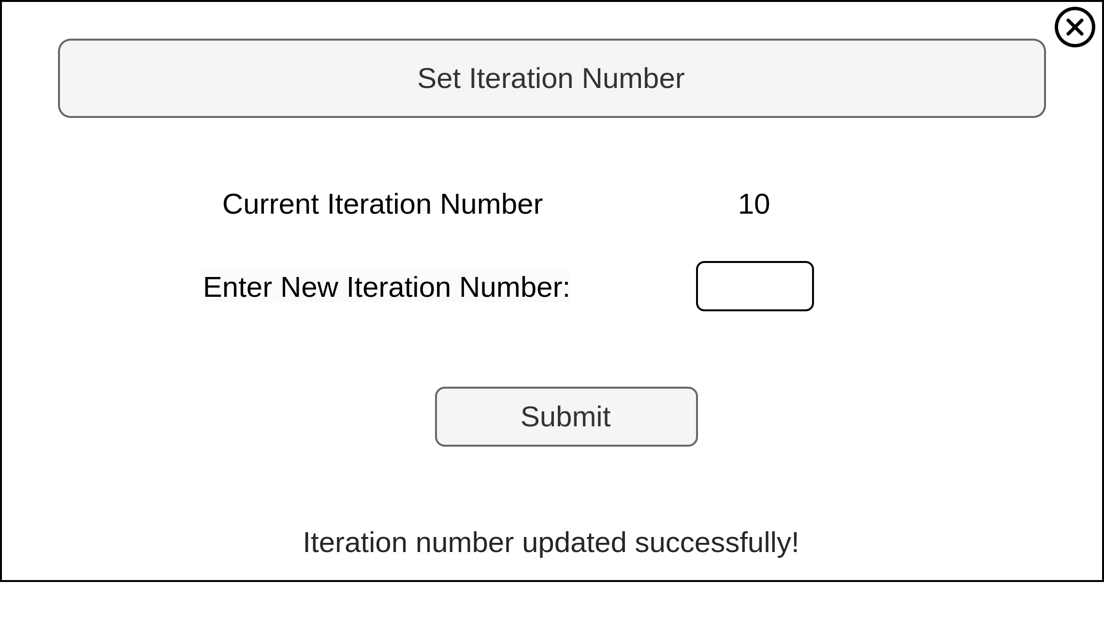  
"Set iteration number" mock-up form

Detailed use case for "Set iteration number" task  
O - Occurrence, CL - Cognitive Level, S - Normalized Salary, SC - Step Cost

| **Step** | **O** | **CL** | **S** | **SC** |
| --- | --- | --- | --- | --- |
| **1** **ACTOR** opens "Set Iteration Number" form. | 1 | 1 | 2.5 | 2.5 |
| **2** **SYSTEM** displays the current iteration number. |  |  |  |  |
| **3.1** **IF** it’s the first configuration: |  |  |  |  |
| **3.1.1** **ACTOR** inputs the desired number of iterations based on task complexity and previous experience. | 0.002 | 3 | 2.5 | 0.015 |
| **3.2** **ELSE** (subsequent configurations): |  |  |  |  |
| **3.2.1** **ACTOR** inputs the number based on the established learning curve. | 0.998 | 1 | 2.5 | 2.495 |
| **4** **ACTOR** clicks "Submit" button to confirm the iteration number. | 1 | 1 | 2.5 | 2.5 |
| **5** **SYSTEM** shows a confirmation dialog. |  |  |  |  |
| **6** **ACTOR** closes the form. | 1 | 1 | 2.5 | 2.5 |
| Human task cost | | | | 10.01 |

### Check learning report

[*Paolo Palumbo*]

The task is performed by a ML engineer.

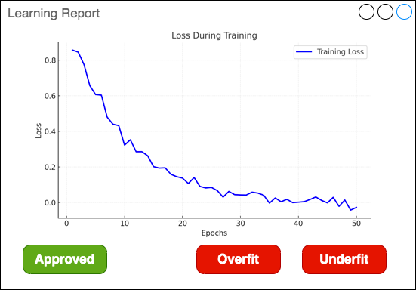

"Check learning report" mock-up form

Detailed use case for "Check training report" task  
O - Occurrence, CL - Cognitive Level, S - Normalized Salary, SC - Step Cost

| **Step** | **O** | **CL** | **S** | **SC** |
| --- | --- | --- | --- | --- |
| **1** **ACTOR** opens "Check training report" form. | 1 | 1 | 2.50 | 2.50 |
| **2** **SYSTEM** shows the training loss curve. |  |  |  |  |
| **3** **ACTOR** checks the learning curve. | 1 | 3 | 2.50 | 7.50 |
| **3.1** **IF** the loss is flat for at least half of the iterations: | 0.4 |  |  |  |
| **3.1.1** **THEN** **ACTOR** clicks "Overfit" button. | 0.4 | 1 | 2.50 | 1.00 |
| **3.2** **IF** the loss is not flat at the end of the iterations: | 0.4 |  |  |  |
| **3.2.1** **THEN** **ACTOR** clicks "Underfit" button. | 0.4 | 1 | 2.50 | 1.00 |
| **3.3** **ELSE** | 0.2 |  |  |  |
| **3.3.1** **ACTOR** clicks "Approved" button. | 0.2 | 1 | 2.50 | 0.50 |
| **4** **SYSTEM** shows a confirmation dialog. |  |  |  |  |
| **5** **ACTOR** closes the form. | 1 | 1 | 2.50 | 2.50 |
| Human task cost | | | | 15 |

### Check validation report

[*Ettore Ricci*]

This task is performed by a ML engineer.

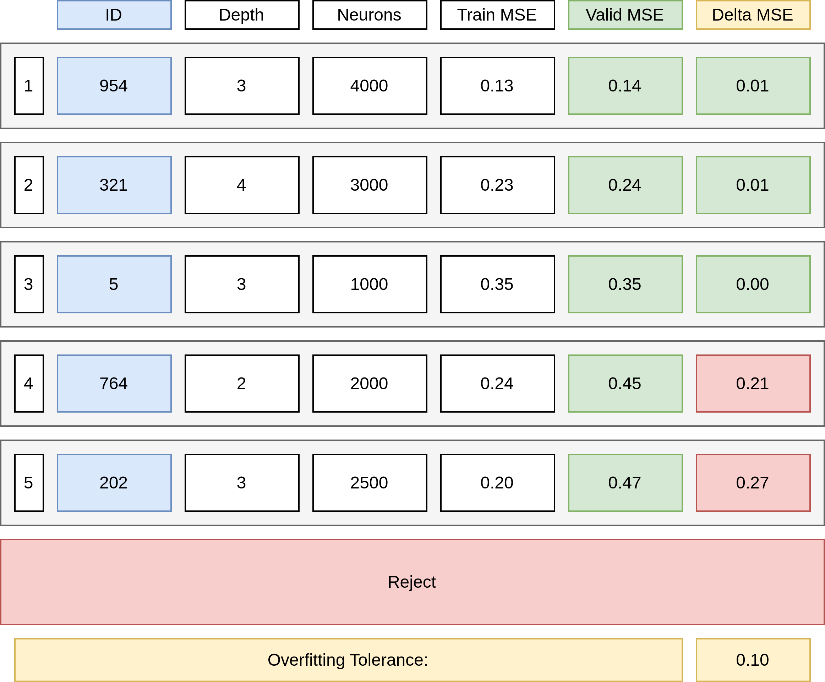

"Check validation report" mock-up form

Detailed use case for "Check validation report" task  
O - Occurrence, CL - Cognitive Level, S - Normalized Salary, SC - Step Cost

| **Step** | **O** | **CL** | **S** | **SC** |
| --- | --- | --- | --- | --- |
| **1** **ACTOR** opens "Check validation report" form. | 1 | 1 | 2.5 | 2.5 |
| **2** **SYSTEM** shows the best 5 models sorted by increasing Validation Loss. |  |  |  |  |
| **3** **FOR EACH** model in the list: | 5 |  |  |  |
| **3.1** **ACTOR** calculates model Validation Loss minus the Training Loss | 1 | 3 | 2.5 | 7.5 |
| **3.2** **IF 3.1** is less than the Overfitting Tolerance and the Best Model is not selected. | 1 | 3 | 2.5 | 7.5 |
| **3.2.1** **THEN ACTOR** selects the model as the Best Model. | 1 | 1 | 2.5 | 2.5 |
| **4** **FOR EACH** model in the list aside form the previous: | 4 |  |  |  |
| **4.1** **ACTOR** calculates model Validation Loss minus the Training Loss | 1 | 3 | 2.5 | 7.5 |
| **4.2** **IF 4.1** is less than the Overfitting Tolerance and the Second Best Model is not selected. | 1 | 3 | 2.5 | 7.5 |
| **4.2.1** **THEN** select the model as the Second Best Model. | 0.25 | 1 | 2.5 | 0.625 |
| **5** **ACTOR** calculates if the Validation Loss of the Second Best Model is one order of magnitude greater than the Validation Loss of the Best Model. | 1 | 3 | 2.5 | 7.5 |
| **6.1** **IF** the Best Model is not selected. | 0.05 | 1 | 2.5 | 0.125 |
| **6.1.1** **ACTOR** clicks "Reject" button. | 0.05 | 1 | 2.5 | 0.125 |
| **6.2** **ELSE IF** the Second Best Model is not selected or **5** is true | 0.3 | 3 | 2.5 | 2.25 |
| **6.2.1** **ACTOR** clicks on the Best Model. | 0.3 | 1 | 2.5 | 0.75 |
| **6.3** **ELSE** | 0.65 | 3 | 2.5 | 4.875 |
| **6.3.1** **ACTOR** clicks on the least complex model among the Best Model and the Second Best Model. | 0.65 | 3 | 2.5 | 4.875 |
| **7** **SYSTEM** shows a confirmation dialog. |  |  |  |  |
| **8** **ACTOR** closes the form. | 1 | 1 | 2.5 | 2.5 |
| Human task cost | | | | 175.5 |

### 

### Check test results

[*Ettore Ricci*]

This task is performed by a ML engineer.

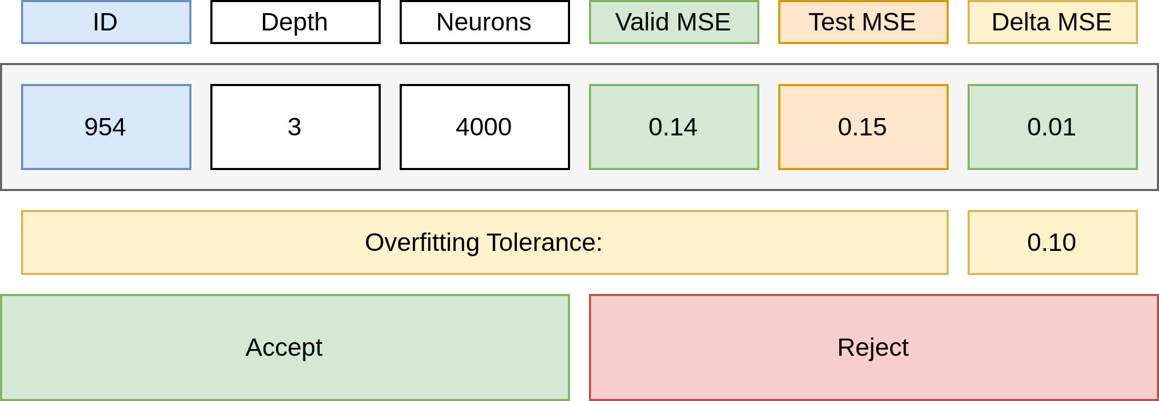

"Check test results" mock-up form

Detailed use case for "Check test results" task  
O - Occurrence, CL - Cognitive Level, S - Normalized Salary, SC - Step Cost

| **Step** | **O** | **CL** | **S** | **SC** |
| --- | --- | --- | --- | --- |
| **1** **ACTOR** opens "Check test results" form. | 1 | 1 | 2.5 | 2.5 |
| **2** **SYSTEM** shows the test results. |  |  |  |  |
| **3** **ACTOR** checks if the difference between the test results and the validation results is within overfitting tolerance. | 1 | 2 | 2.5 | 5 |
| **4.1** **IF** the test results is not satisfactory. | 0.01 |  |  |  |
| **4.1.1** **ACTOR** clicks "Reject" button. | 0.01 | 1 | 2.5 | 0.025 |
| **4.2** **ELSE** | 0.99 |  |  |  |
| **4.2.1** **ACTOR** clicks "Approve" button. | 0.99 | 1 | 2.5 | 2.475 |
| **5** **SYSTEM** shows a confirmation dialog. |  |  |  |  |
| **6** **ACTOR** closes the form. | 1 | 1 | 2.5 | 2.5 |
| Human task cost | | | | 12.5 |

### 

### Configure Development System

[*Francesco Boldrini, Zahra Omrani*]

This task is performed by a ML Engineer.

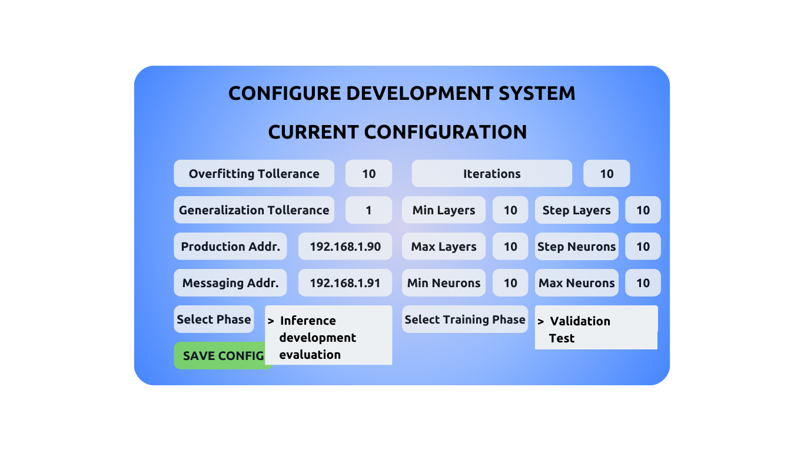

"Configure Development System" mock-up form

Detailed use case for "Configure Development" task  
O - Occurrence, CL - Cognitive Level, S - Normalized Salary, SC - Step Cost

| **Step** | **O** | **CL** | **S** | **SC** |
| --- | --- | --- | --- | --- |
| **1** **ACTOR** opens the "Configure Development System" form. | 1 | 1 | 2.50 | 2.50 |
| **2** **SYSTEM** displays current configuration. |  |  |  |  |
| **3** **ACTOR** sets the min_layers. | 1 | 4 | 2.50 | 10 |
| **4** **ACTOR** sets the max_layers. | 1 | 4 | 2.50 | 10 |
| **5** **ACTOR** sets the min_neurons. | 1 | 4 | 2.50 | 10 |
| **6** **ACTOR** sets the step_layers. | 1 | 4 | 2.50 | 10 |
| **7** **ACTOR** sets the step_neurons. | 1 | 4 | 2.50 | 10 |
| **8** **ACTOR** sets the max_neurons. | 1 | 4 | 2.50 | 10 |
| **9** **ACTOR** sets the overfitting_tolerance parameter. | 1 | 4 | 2.50 | 10 |
| **10** **ACTOR** sets the generalization_tolerance parameter. | 1 | 4 | 2.50 | 10 |
| **11** **ACTOR** sets the iterations parameter. | 1 | 4 | 2.50 | 10 |
| **12** **ACTOR** choose the training_phase parameter from the drop down (validation, test). | 1 | 1 | 2.50 | 2.50 |
| **13** **ACTOR** sets the production_sys_addr parameter. | 1 | 1 | 2.50 | 2.50 |
| **14** **ACTOR** sets the messaging_sys_addr parameter. | 1 | 1 | 2.50 | 2.50 |
| **15** **ACTOR** choose the phase parameter from the drop down (inference, develop, evaluation) . | 1 | 1 | 2.50 | 2.50 |
| **16.1** **SYSTEM** IF config is correct and correctly formatted. |  |  |  |  |
| **16.1.1** **SYSTEM** shows a confirmation message. |  |  |  |  |
| **16.2** **ELSE** |  |  |  |  |
| **16.2.1** **SYSTEM** shows error message and aborts. |  |  |  |  |
| **17** **ACTOR** saves the form. | 1 | 1 | 2.50 | 2.50 |
| Human task cost | | | | 105 |

## 

## Evaluation system

### Evaluate classifier performance

[*Zahra Omrani*]

This task is performed by a Data Analyst.

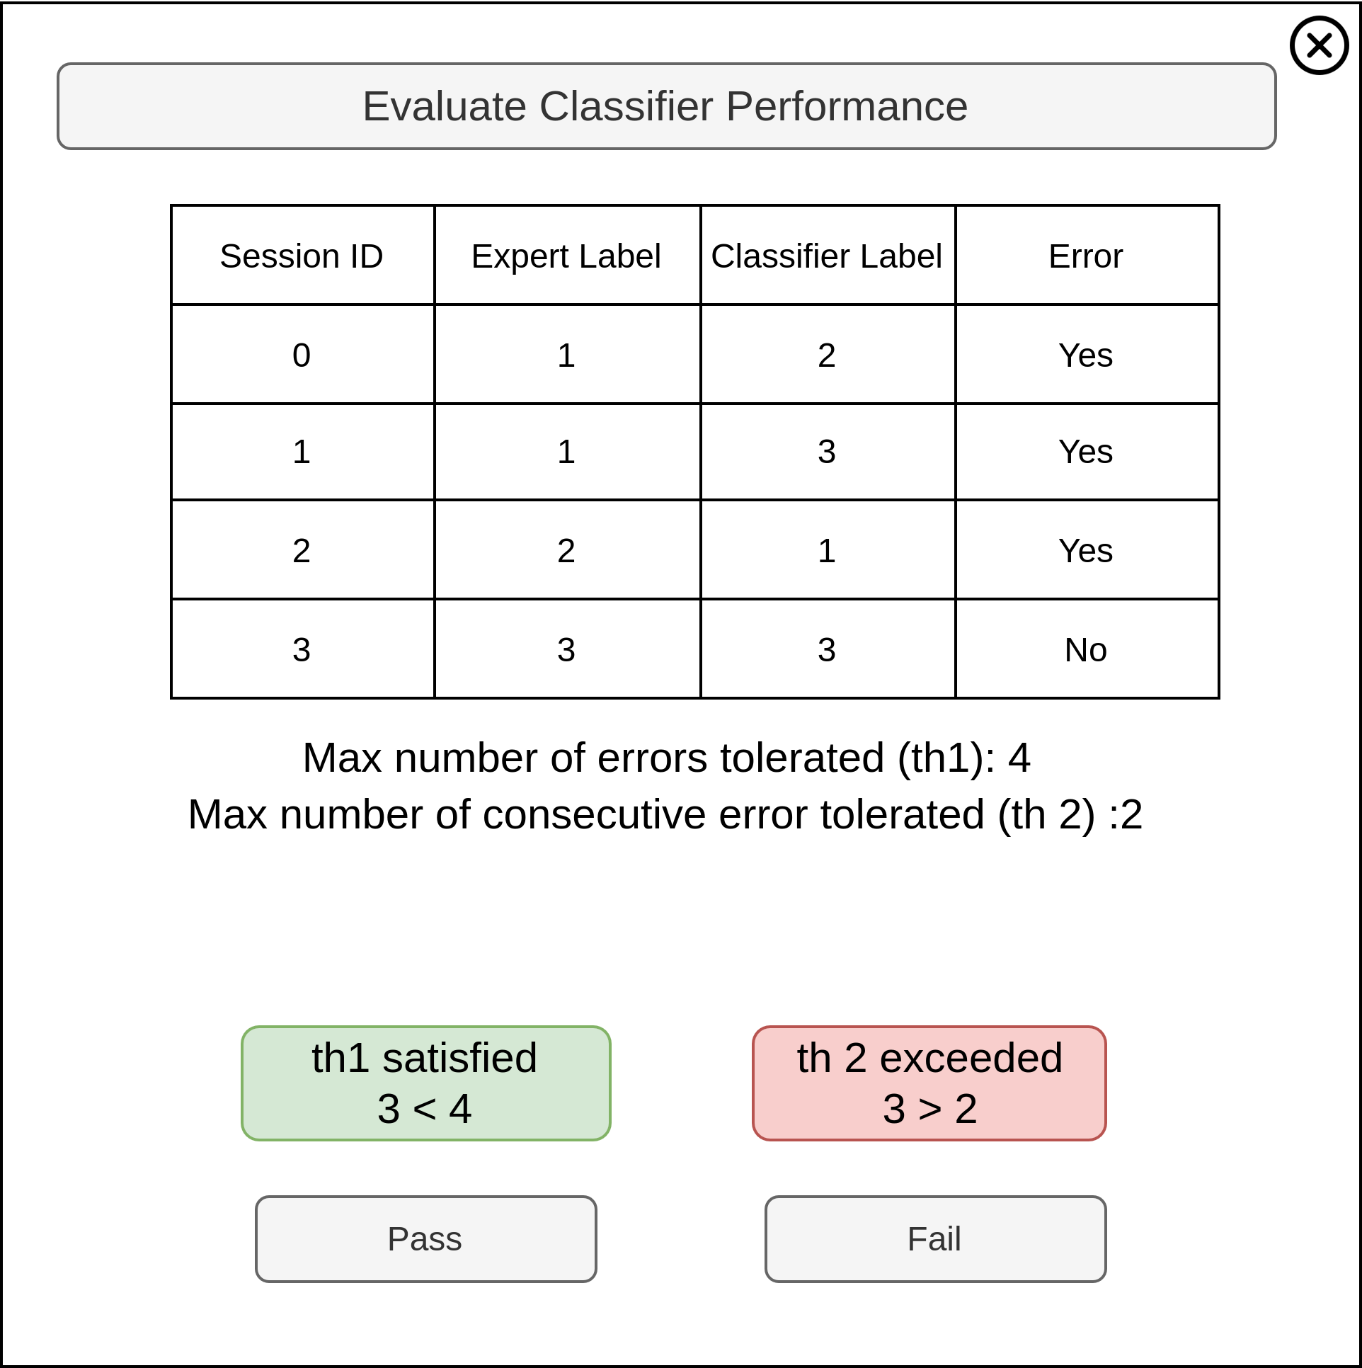

"Evaluate Classifier Performance" mock-up form

Detailed use case for "Evaluate Classifier Performance" task  
O - Occurrence, CL - Cognitive Level, S - Normalized Salary, SC - Step Cost

| **Step** | **O** | **CL** | **S** | **SC** |
| --- | --- | --- | --- | --- |
| **1** **ACTOR** opens the "Evaluate Classifier Performance" form. | 1 | 1 | 1.15 | 1.15 |
| **2** **SYSTEM** displays a table of sessions with Expert Label (ground truth) and Classifier Label (predicted label). The difference between the labels (if any) represents an error. |  |  |  |  |
| **3.1** **ACTOR** checks the total errors threshold color. | 1 | 2 | 1.15 | 2.30 |
| **3.2** **ACTOR** checks the consecutive errors threshold color | 1 | 2 | 1.15 | 2.30 |
| **3.3** **IF** at least one threshold is red |  |  |  |  |
| **3.3.1** **ACTOR** clicks the "Fail" button. | 0.14 | 1 | 1.15 | 0.161 |
| **3.4** **ELSE** |  |  |  |  |
| **3.4.1** **ACTOR** clicks the "Pass" button. | 0.86 | 1 | 1.15 | 0.989 |
| **4** **SYSTEM** shows a confirmation dialog. |  |  |  |  |
| **5** **ACTOR** closes the form. | 1 | 1 | 1.15 | 1.15 |
| Human task cost | | | | 8.05 |

### Configure Evaluation System

[*Francesco Boldrini, Zahra Omrani*]

This task is performed by a ML Engineer.

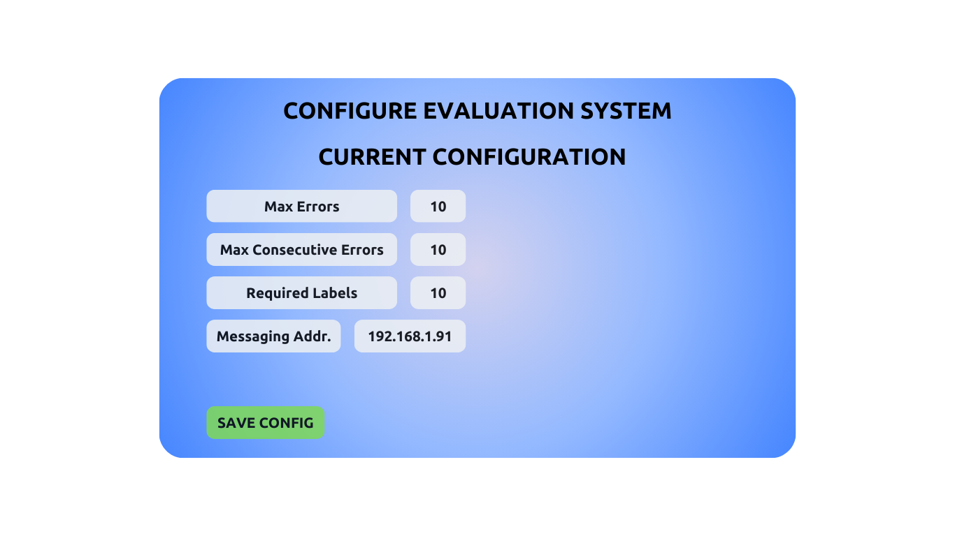

"Configure Evaluation System" mock-up form

Detailed use case for "Configure Evaluation" task  
O - Occurrence, CL - Cognitive Level, S - Normalized Salary, SC - Step Cost

| **Step** | **O** | **CL** | **S** | **SC** |
| --- | --- | --- | --- | --- |
| **1** **ACTOR** opens the "Configure Evaluation System" form. | 1 | 1 | 2.50 | 2.50 |
| **2** **SYSTEM** displays current configuration. |  |  |  |  |
| **3** **ACTOR** sets the max_errors parameter. | 1 | 4 | 2.50 | 10 |
| **4** **ACTOR** sets the max_consecutive_errors parameter. | 1 | 4 | 2.50 | 10 |
| **5** **ACTOR** sets the required_labels parameter. | 1 | 4 | 2.50 | 10 |
| **6** **ACTOR** sets the messaging_sys_addr parameter. | 1 | 1 | 2.50 | 2.50 |
| **7.1** **SYSTEM** IF config is correct and correctly formatted. |  |  |  |  |
| **7.1.1** **SYSTEM** shows a confirmation message. |  |  |  |  |
| **7.2** **ELSE** |  |  |  |  |
| **7.2.1** **SYSTEM** shows error message and aborts. |  |  |  |  |
| **9** **ACTOR** saves the form. | 1 | 1 | 2.50 | 2.50 |
| Human task cost | | | | 37.50 |

## Client-Side Systems

### Configure Client-Side Systems

[*Francesco Boldrini, Zahra Omrani*]

This task is performed by a ML Engineer.

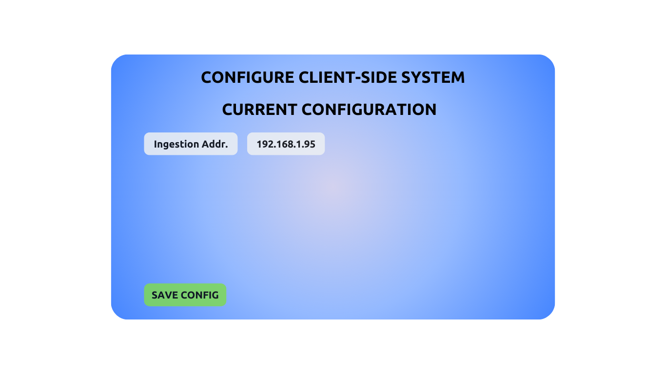

"Configure Client-Side Systems" mock-up form

Detailed use case for "Configure Client-Side Systems" task  
O - Occurrence, CL - Cognitive Level, S - Normalized Salary, SC - Step Cost

| **Step** | **O** | **CL** | **S** | **SC** |
| --- | --- | --- | --- | --- |
| **1** **ACTOR** opens the "Configure Client-Side System" form. | 1 | 1 | 2.50 | 2.50 |
| **2** **SYSTEM** displays current configuration. |  |  |  |  |
| **3** **ACTOR** sets the ingestion_sys_addr parameter. | 1 | 1 | 2.50 | 2.50 |
| **4.1** **SYSTEM** IF config is correct and correctly formatted. |  |  |  |  |
| **4.1.1** **SYSTEM** shows a confirmation message. |  |  |  |  |
| **4.2** **ELSE** |  |  |  |  |
| **4.2.1** **SYSTEM** shows error message and aborts. |  |  |  |  |
| **5** **ACTOR** saves the form. | 1 | 1 | 2.50 | 2.50 |
| Human task cost | | | | 7.50 |

## Production System

### Configure Production Systems

[*Francesco Boldrini, Zahra Omrani*]

This task is performed by a ML Engineer.

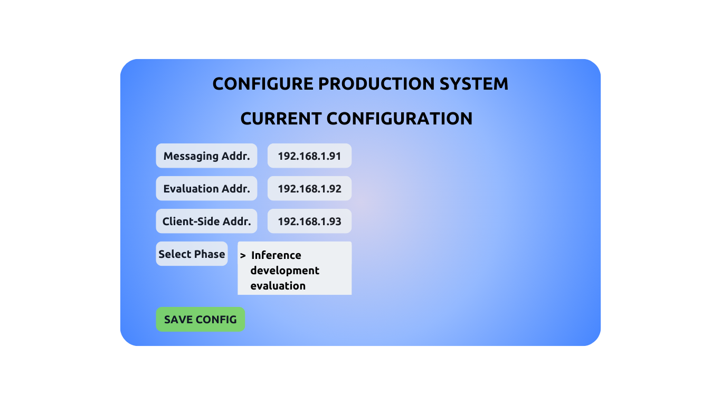

"Configure Production System" mock-up form

Detailed use case for "Configure Production" task  
O - Occurrence, CL - Cognitive Level, S - Normalized Salary, SC - Step Cost

| **Step** | **O** | **CL** | **S** | **SC** |
| --- | --- | --- | --- | --- |
| **1** **ACTOR** opens the "Configure Production System" form. | 1 | 1 | 2.50 | 2.50 |
| **2** **SYSTEM** displays current configuration. |  |  |  |  |
| **3** **ACTOR** sets the production_sys_addr parameter. | 1 | 1 | 2.50 | 2.50 |
| **4** **ACTOR** sets the messaging_sys_addr parameter. | 1 | 1 | 2.50 | 2.50 |
| **5** **ACTOR** choose the phase parameter from the drop down (inference, develop, evaluation). | 1 | 1 | 2.50 | 2.50 |
| **6.1** **SYSTEM** IF config is correct and correctly formatted. |  |  |  |  |
| **6.1.1** **SYSTEM** shows a confirmation message. |  |  |  |  |
| **6.2** **ELSE** |  |  |  |  |
| **6.2.1** **SYSTEM** shows error message and aborts. |  |  |  |  |
| **7** **ACTOR** saves the form. | 1 | 1 | 2.50 | 2.50 |
| Human task cost | | | | 12.50 |

## Ingestion System

### Configure Ingestion System

[*Francesco Boldrini, Zahra Omrani*]

This task is performed by a ML Engineer.

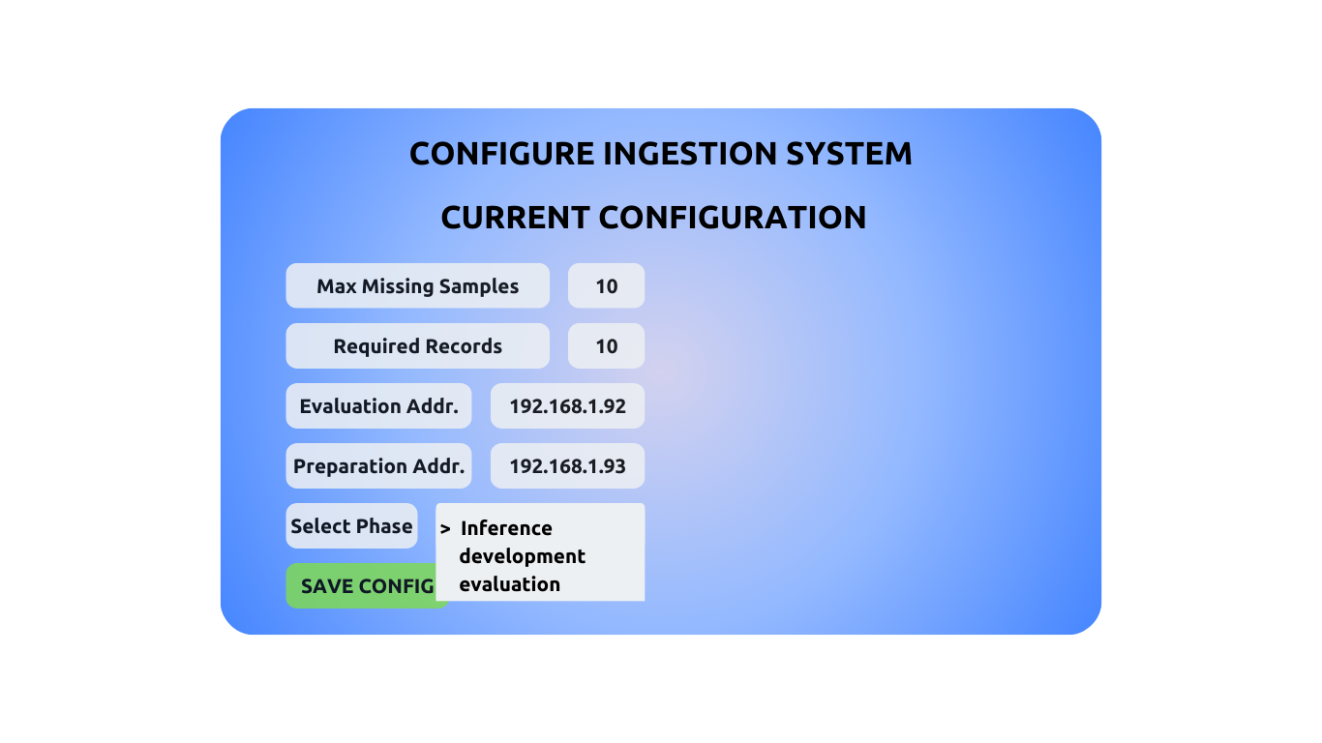

"Configure Ingestion System" mock-up form

Detailed use case for "Configure Ingestion System" task

| **Step** | **O** | **CL** | **S** | **SC** |
| --- | --- | --- | --- | --- |
| **1** **ACTOR** opens the "Configure Ingestion System" form. | 1 | 1 | 2.50 | 2.50 |
| **2** **SYSTEM** displays the current configuration. |  |  |  |  |
| **3** **ACTOR** sets the max_missing_samples. | 1 | 4 | 2.50 | 10 |
| **4** **ACTOR** sets the required_records. | 1 | 4 | 2.50 | 10 |
| **5** **ACTOR** sets the evaluation_sys_addr. | 1 | 1 | 2.50 | 2.50 |
| **6** **ACTOR** sets the preparation_sys_addr. | 1 | 1 | 2.50 | 2.50 |
| **7** **ACTOR** selects the phase from the dropdown (inference, development, evaluation). | 1 | 1 | 2.50 | 2.50 |
| **8.1** **SYSTEM** IF the configurations are correct and properly formatted: |  |  |  |  |
| **8.1.1** **SYSTEM** displays a confirmation message. |  |  |  |  |
| **8.2** **ELSE** (if the configurations are incorrect): |  |  |  |  |
| **8.2.1** **SYSTEM** displays an error message and aborts the process. |  |  |  |  |
| **9** **ACTOR** saves the form. | 1 | 1 | 2.50 | 2.50 |
| Human task cost | | | | 32.5 |

## Preparation System

### Configure Preparation System

[*Francesco Boldrini, Zahra Omrani*]

This task is performed by a ML Engineer.

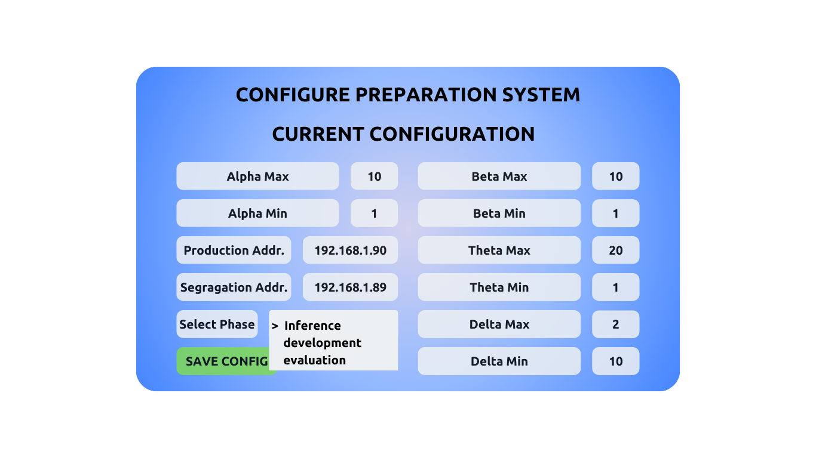

"Configure Preparation System" mock-up form

Detailed use case for "Configure Preparation System" task

| **Step** | **O** | **CL** | **S** | **SC** |
| --- | --- | --- | --- | --- |
| **1** **ACTOR** opens the "Configure Preparation System" form. | 1 | 1 | 2.50 | 2.50 |
| **2** **SYSTEM** displays the current configuration. |  |  |  |  |
| **3** **ACTOR** sets the alpha_max. | 1 | 4 | 2.50 | 10 |
| **4** **ACTOR** sets the alpha_min. | 1 | 4 | 2.50 | 10 |
| **5** **ACTOR** sets the beta_max. | 1 | 4 | 2.50 | 10 |
| **6** **ACTOR** sets the beta_min. | 1 | 4 | 2.50 | 10 |
| **7** **ACTOR** sets the theta_max. | 1 | 4 | 2.50 | 10 |
| **8** **ACTOR** sets the theta_min. | 1 | 4 | 2.50 | 10 |
| **9** **ACTOR** sets the delta_max. | 1 | 4 | 2.50 | 10 |
| **10** **ACTOR** sets the delta_min. | 1 | 4 | 2.50 | 10 |
| **11** **ACTOR** sets the production_sys_addr. | 1 | 1 | 2.50 | 2.50 |
| **12** **ACTOR** sets the segregation_sys_addr. | 1 | 1 | 2.50 | 2.50 |
| **13** **ACTOR** selects the phase from the dropdown (inference, develop, evaluation). | 1 | 1 | 2.50 | 2.50 |
| **14** **SYSTEM** IF the configuration is correct and properly formatted: |  |  |  |  |
| **14.1** **SYSTEM** displays a confirmation message. |  |  |  |  |
| **14.2** **ELSE** (if the configuration is incorrect): |  |  |  |  |
| **14.2.1** **SYSTEM** displays an error message and aborts the process. |  |  |  |  |
| **15** **ACTOR** saves the form. | 1 | 1 | 2.50 | 2.50 |
| **Human task cost** | | | | 92.5 |

# Simulation

## Collapsed workflow

[*Ettore Ricci, Paolo Palumbo, Francesco Boldrini*]

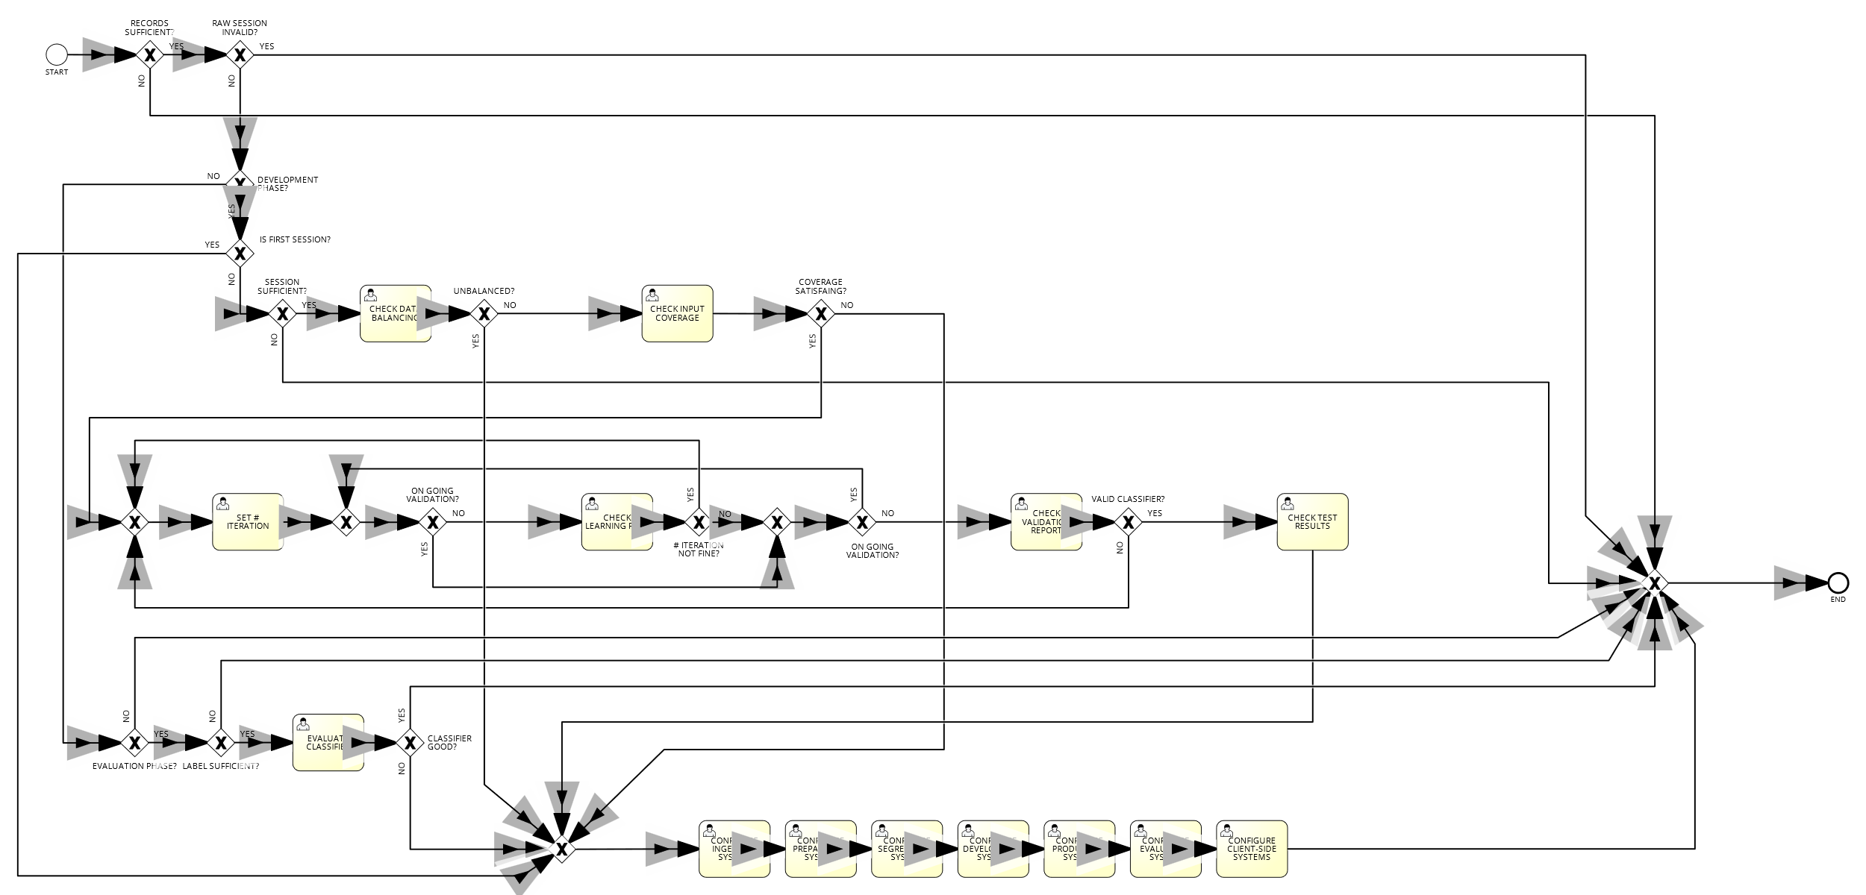

Collapsed workflow

## AS-IS Simulation

[*Francesco Boldrini, Zahra Omrani*]

NB: we set the total number of initial process instances to 6852, as with our assumptions for the two initial gates, where we discard 10% of the sessions twice, we need 6852 sessions to start, to work with the documentation’s assumptions of the 5550 good sessions for all phases altogethe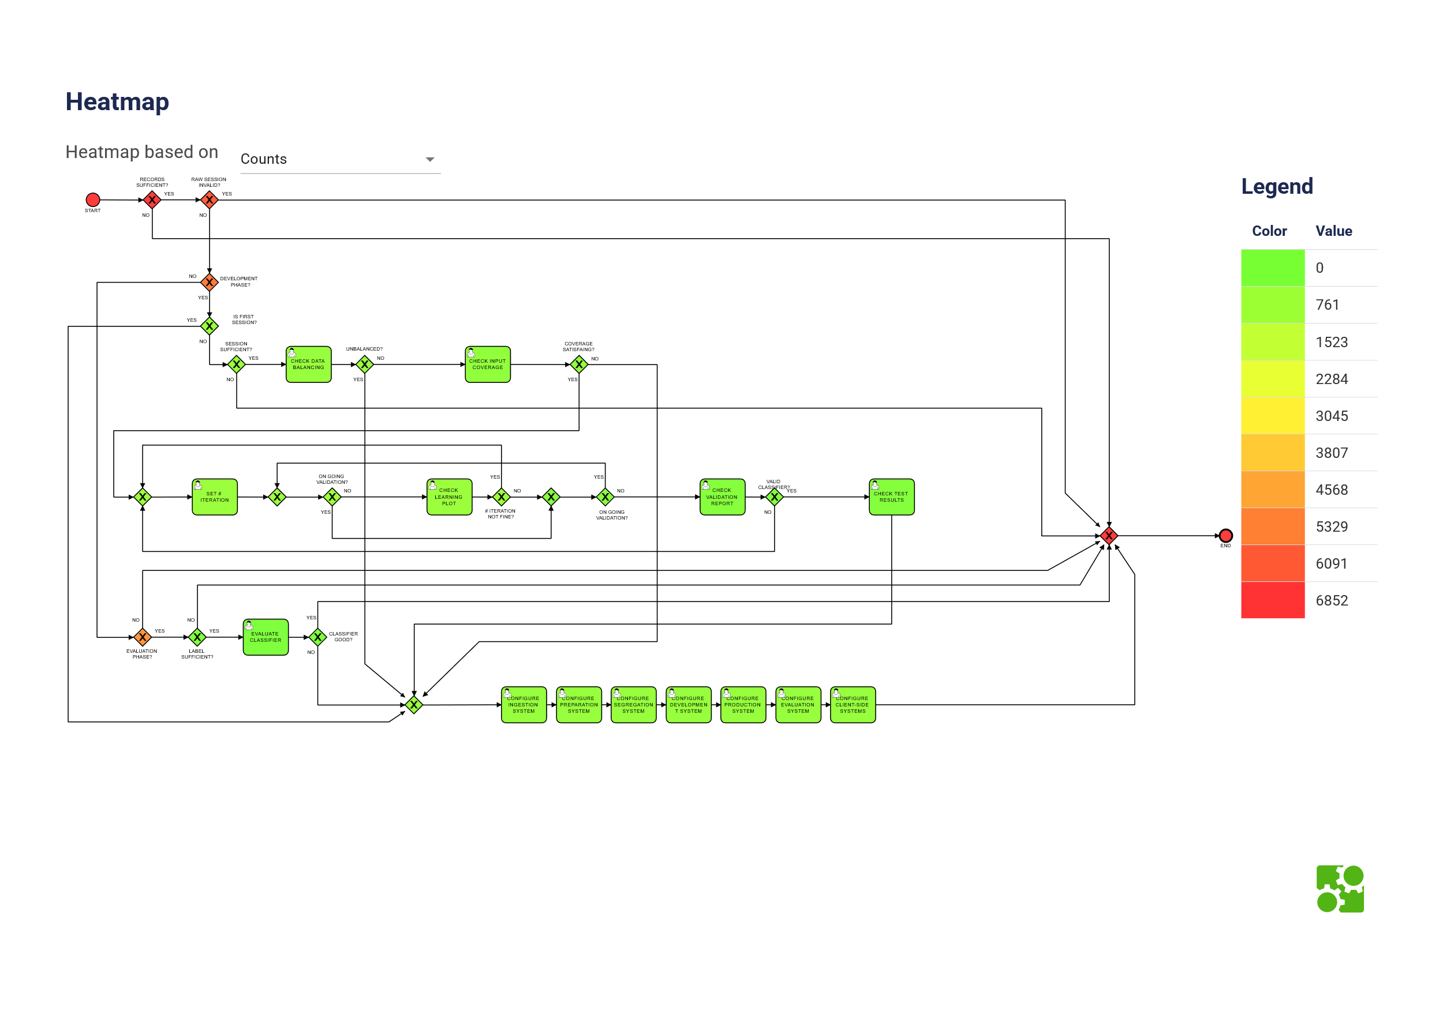

AS-IS Heatmap of the counts of the parameters

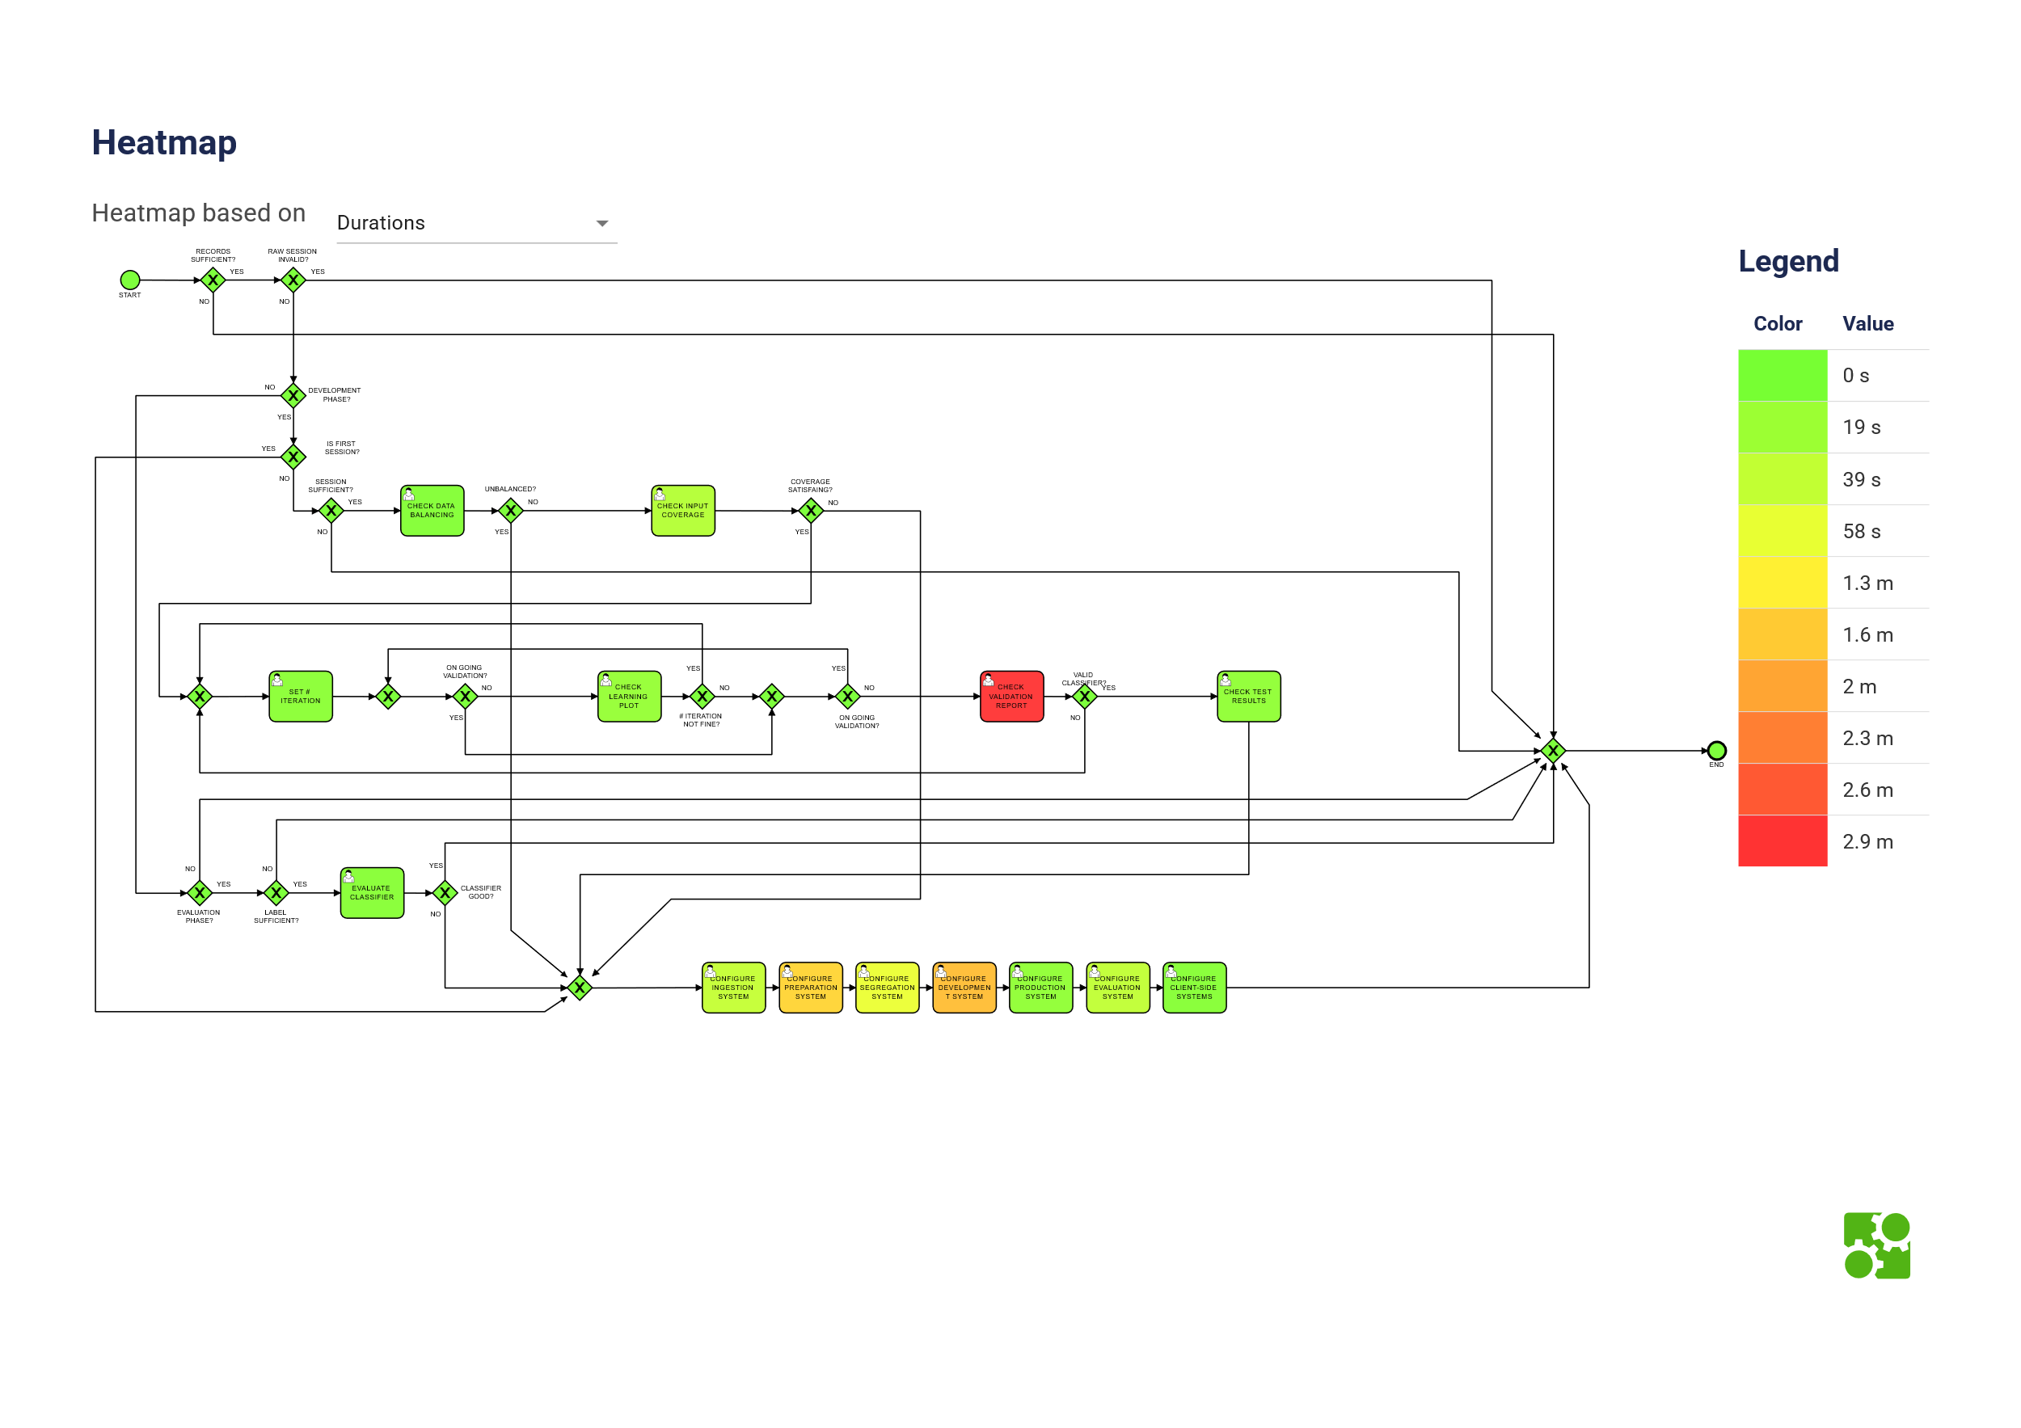

AS-IS Heatmap of the time spent in each passage [Durations]

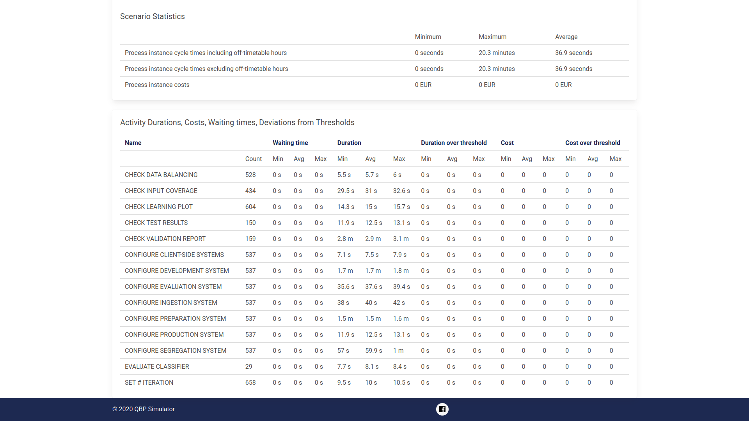

AS-IS Simulation Results

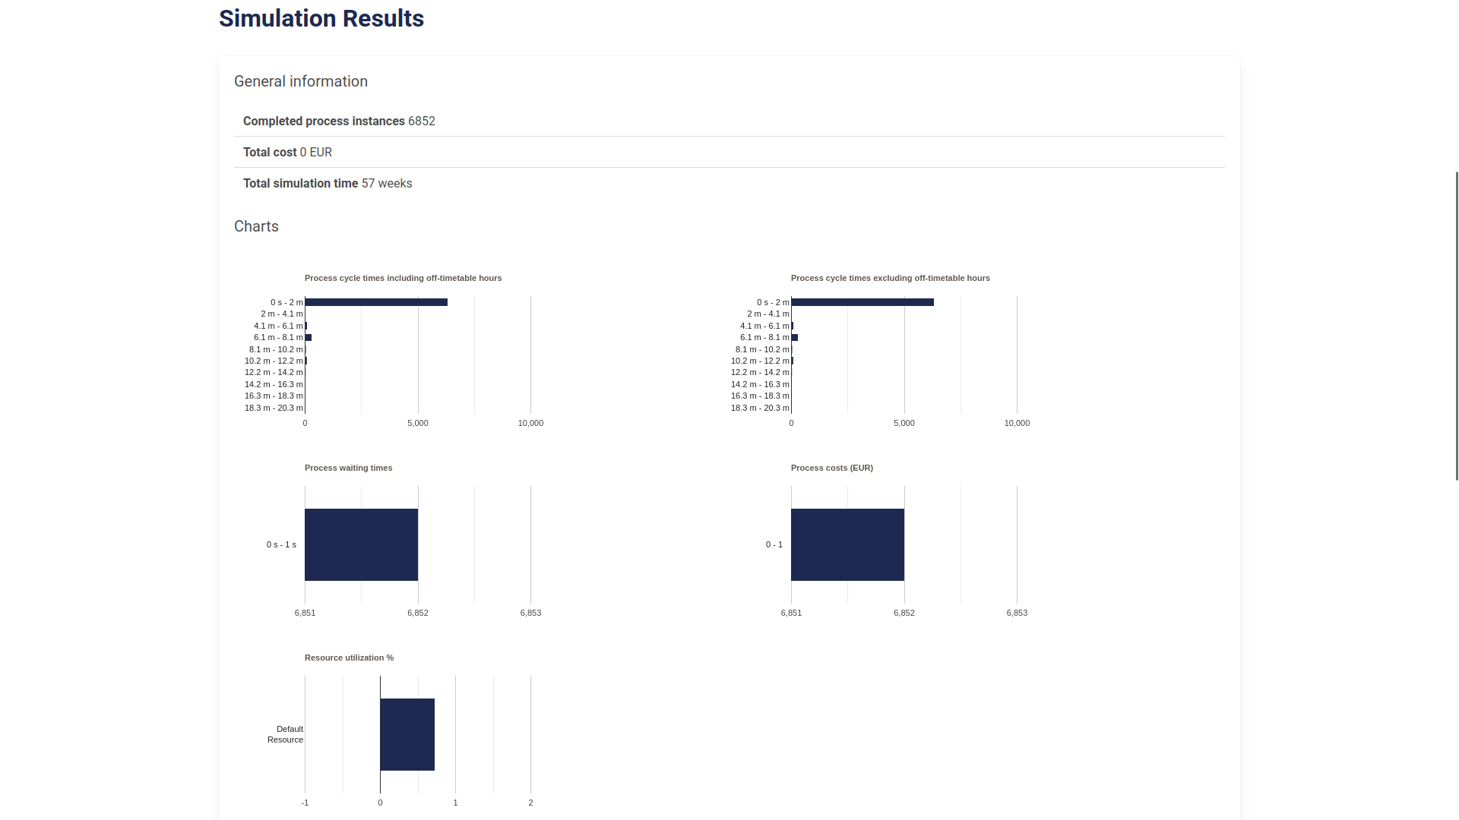

AS-IS Scenario Statistics

| **Parameter** | **% of the Gate** | **Motivation** |
| --- | --- | --- |
| # Iteration not fine? | 20% | According to the assumptions of the |
|  |  | documentation, we set the % of iters |
|  |  | that are not fine to 20% |
| Classifier Good? | 86% | According to the assumptions of the |
|  |  | docs, classifiers are good 86 of the time |
| Coverage satisfying? | 33% | According to the assumptions of the |
|  |  | docs, coverage is satisfying 33% of the time |
| Development Phase? | 9% | In this gate, out of 5550, 500 are |
|  |  | in the development phase |
| Is First Session? | 1% | In this gate, out of 500, 1 is |
|  |  | in the first session, but the gate |
|  |  | won’t load less than 1% on BIMP |
| Labels sufficient? | 71% | Given 5550 good sessions, and |
|  |  | assuming that those will yields |
|  |  | 5 proper classifiers, given the |
|  |  | probabilities at the preceding |
|  |  | gates and the rounding because of |
|  |  | necessity of the gate to have at |
|  |  | least 1% as value, we |
|  |  | need to have 71% of the sessions |
|  |  | to have sufficient labels to respect |
|  |  | the documentation’s assumptions. |
| On going Validation? | 90% | We set validation to 90% as most |
|  |  | of the times this step involves the |
|  |  | autonomous systems and not humans |
| Raw session Invalid? | 10% | We assume that 90% of the times |
|  |  | the raw session is valid. |
| Records Sufficient? | 90% | We assume that 90% of the times |
|  |  | the records are sufficient. |
| Session Sufficient? | 99% | We set sessions sufficient to 99% as |
|  |  | with the document’s assumptions, we |
|  |  | would need roughly 545 sessions to |
|  |  | have 5 final good classifiers and here |
|  |  | we already start with 500, which is |
|  |  | already lower than what we would need. |
| Unbalanced? | 20% | The documentation assumes that |
|  |  | 20% of the classes are balanced |
| Valid Classifier? | 95% | The documentation assumes that |
|  |  | 95% of the classifiers are valid |

## Modeling the TO-BE Process

[*Francesco Boldrini, Zahra Omrani*]

In the context of our application, "Emotion Based Music Selection", we suppose that during the initial configuration phase, we acquire the data through the ECG sensors and the user’s schedules, currently playing music and other relevant informations.

This data could be processed by a research center through data-mining approaches: this would mean simplifying the process and making it more efficient, as we could use existing similar classifiers to initialize ours, rather than starting from scratch.

In fact similar networks and classifiers may work well with similar parameters over similar tasks.

For each category it is possible to define some improvement(s):

1. Hand-Off level Improvement(s): Re-use sessions from similar networks in the same category, rather than collecting other sessions.

2. Service Level Improvement(s): Use hyperparameters from similar networks in the same category, rather than starting from scratch.

3. Task Level Improvement(s): Reduce the cognitive effort necessary for the configurations, by starting from default parameters obtained from other similar networks, rather than starting from scratch.

### Hand-Off level Improvement(s)

[*Francesco Boldrini, Zahra Omrani*]

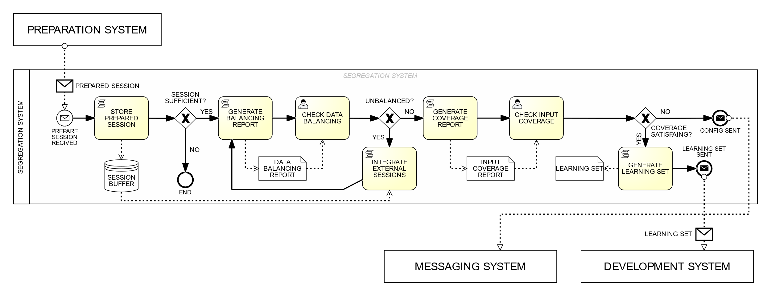

Change to the Generate Learning Sets

We modified the workflow in such a way that our saved previous sessions can be reused in the case of unbalanced data, rather than awaiting for the message system to respond to the issue arisen in the workflow.

This cuts on necessary times to respond to this erroneous situation, as the system can autonomously respond to the issue, rather than waiting for a human to intervene, thus improving the system’s efficiency and re-use of data.

### Service Level Improvement(s)

[*Francesco Boldrini, Zahra Omrani*]

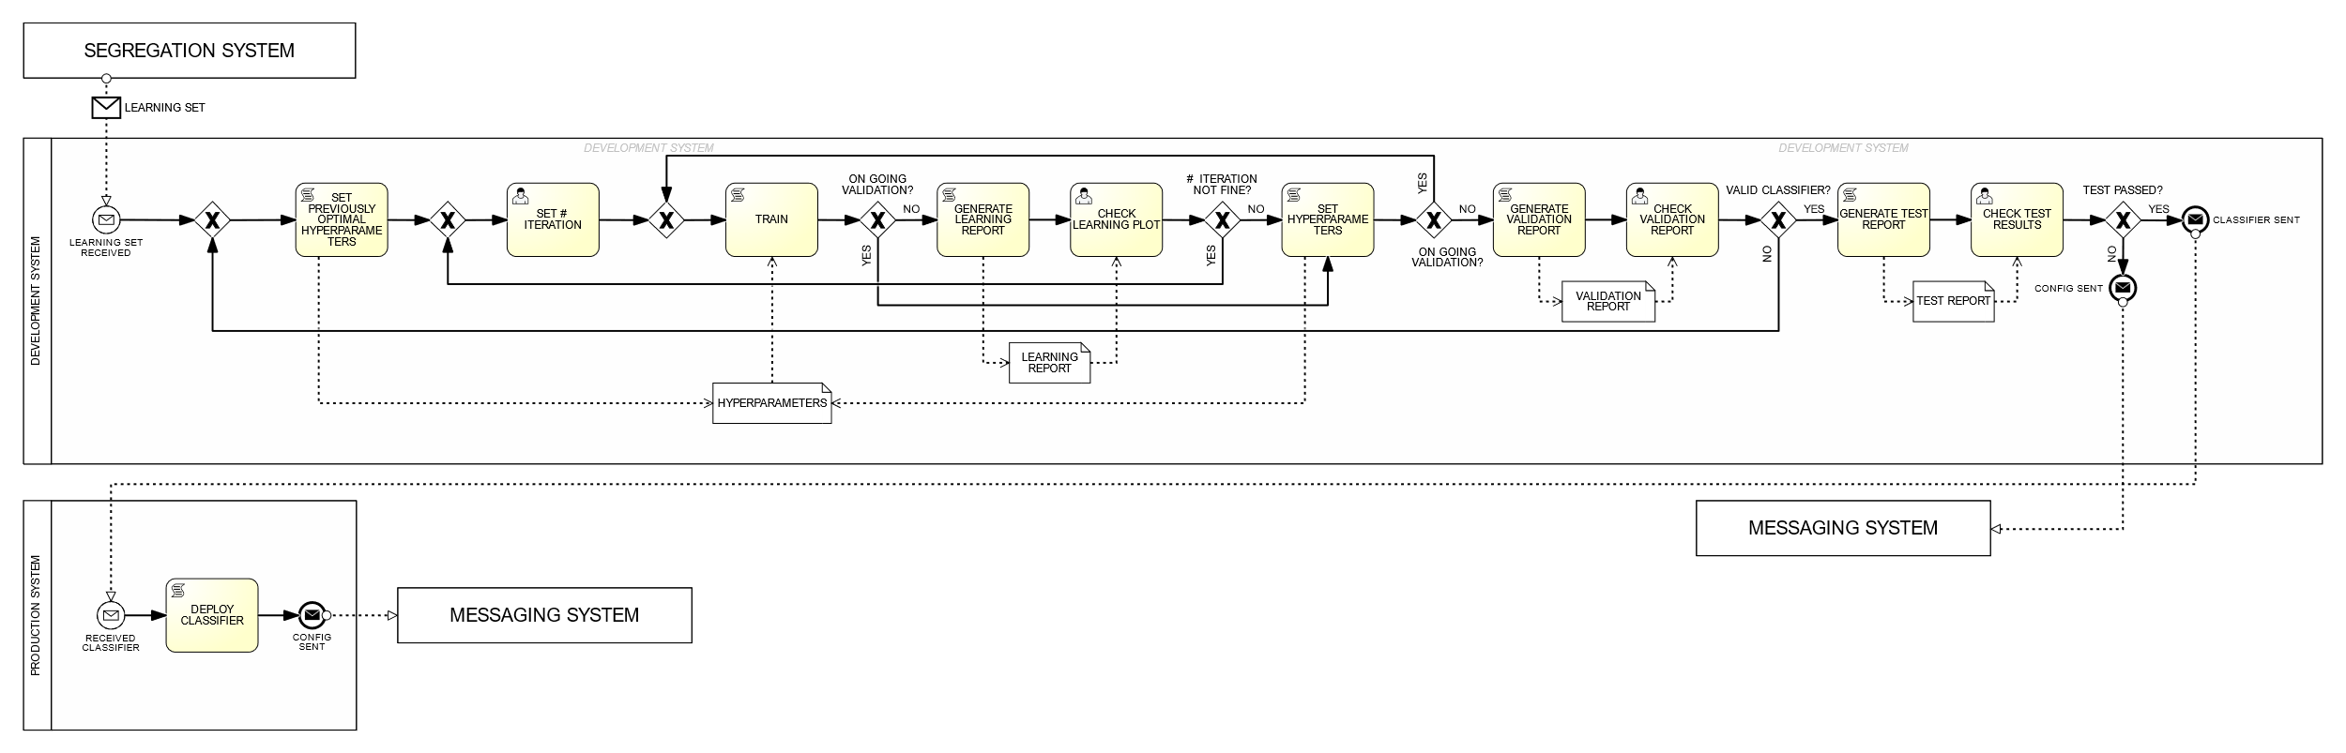

Change to the Develop Classifier

The possibility of using hyperparameters from similar trained networks in the same category, rather than starting from scratch, is a great improvement in the service level.

The search for optimized parameters in the network no longer involves brute-forcing the optimization through a grid-search approach but rather re-uses a functioning network’s parameters, saving time and computational resources.

### Task Level Improvement(s)

[*Francesco Boldrini, Zahra Omrani*]

The task level improvement(s) involve reducing the cognitive effort necessary for the configurations, by starting from default parameters obtained from other similar networks, rather than starting from scratch.

In particular, we removed the need for a grid search in the check validation report, as we no longer need to check amongst the 5 best networks, but simply have to verify that the network respects the overfitting tolerance, as we are using parameters from a similar network in the same category.

Detailed use case for "Check validation report" task  
O - Occurrence, CL - Cognitive Level, S - Normalized Salary, SC - Step Cost

| **Step** | **O** | **CL** | **S** | **SC** |
| --- | --- | --- | --- | --- |
| **1** **ACTOR** opens "Check validation report" form. | 1 | 1 | 2.5 | 2.5 |
| **2** **SYSTEM** shows the model trained on optimal parameters |  |  |  |  |
| **3** **ACTOR** calculates model Validation Loss minus the Training Loss | 1 | 3 | 2.5 | 7.5 |
| **4.1** **IF 3** is less than the Overfitting Tolerance | 0.95 | 3 | 2.5 | 7.125 |
| **3.1.1** **THEN** **ACTOR** Confirms the selected model. | 0.95 | 3 | 2.5 | 7.125 |
| **3.2** **ELSE** **ACTOR** Rejects the selected model. | 0.05 | 3 | 2.5 | 0.375 |
| **6** **SYSTEM** shows a confirmation dialog. |  |  |  |  |
| **7** **ACTOR** closes the form. | 1 | 1 | 2.5 | 2.5 |
| Human task cost | | | | 27.125 $<$ 175.5 |

Furthermore, by using suggested parameters in the configuration phase, we can reduce the cognitive level necessary for the configurations to 2 from 4, by starting from default parameters obtained from other similar networks, rather than needing extensive evaluations (level 4 cognitive level) to find the optimal parameters.

TO-BE detailed use case for "Configure Preparation System" task

| **Step** | **O** | **CL** | **S** | **SC** |
| --- | --- | --- | --- | --- |
| **1** **ACTOR** opens the "Configure Preparation System" form. | 1 | 1 | 2.50 | 2.50 |
| **2** **SYSTEM** displays the current configuration. |  |  |  |  |
| **3** **ACTOR** sets the alpha_max. | 1 | 2 | 2.50 | 5 |
| **4** **ACTOR** sets the alpha_min. | 1 | 2 | 2.50 | 5 |
| **5** **ACTOR** sets the beta_max. | 1 | 2 | 2.50 | 5 |
| **6** **ACTOR** sets the beta_min. | 1 | 2 | 2.50 | 5 |
| **7** **ACTOR** sets the theta_max. | 1 | 2 | 2.50 | 5 |
| **8** **ACTOR** sets the theta_min. | 1 | 2 | 2.50 | 5 |
| **9** **ACTOR** sets the delta_max. | 1 | 2 | 2.50 | 5 |
| **10** **ACTOR** sets the delta_min. | 1 | 2 | 2.50 | 5 |
| **11** **ACTOR** sets the production_sys_addr. | 1 | 1 | 2.50 | 2.50 |
| **12** **ACTOR** sets the segregation_sys_addr. | 1 | 1 | 2.50 | 2.50 |
| **13** **ACTOR** selects the phase from the dropdown (inference, develop, evaluation). | 1 | 1 | 2.50 | 2.50 |
| **14** **SYSTEM** IF the configuration is correct and properly formatted: |  |  |  |  |
| **14.1** **SYSTEM** displays a confirmation message. |  |  |  |  |
| **14.2** **ELSE** (if the configuration is incorrect): |  |  |  |  |
| **14.2.1** **SYSTEM** displays an error message and aborts the process. |  |  |  |  |
| **15** **ACTOR** saves the form. | 1 | 1 | 2.50 | 2.50 |
| **Human task cost** | | | | 52.5 $<$ 92.5 |

## 

## TO-BE Simulation

[*Francesco Boldrini, Zahra Omrani*] 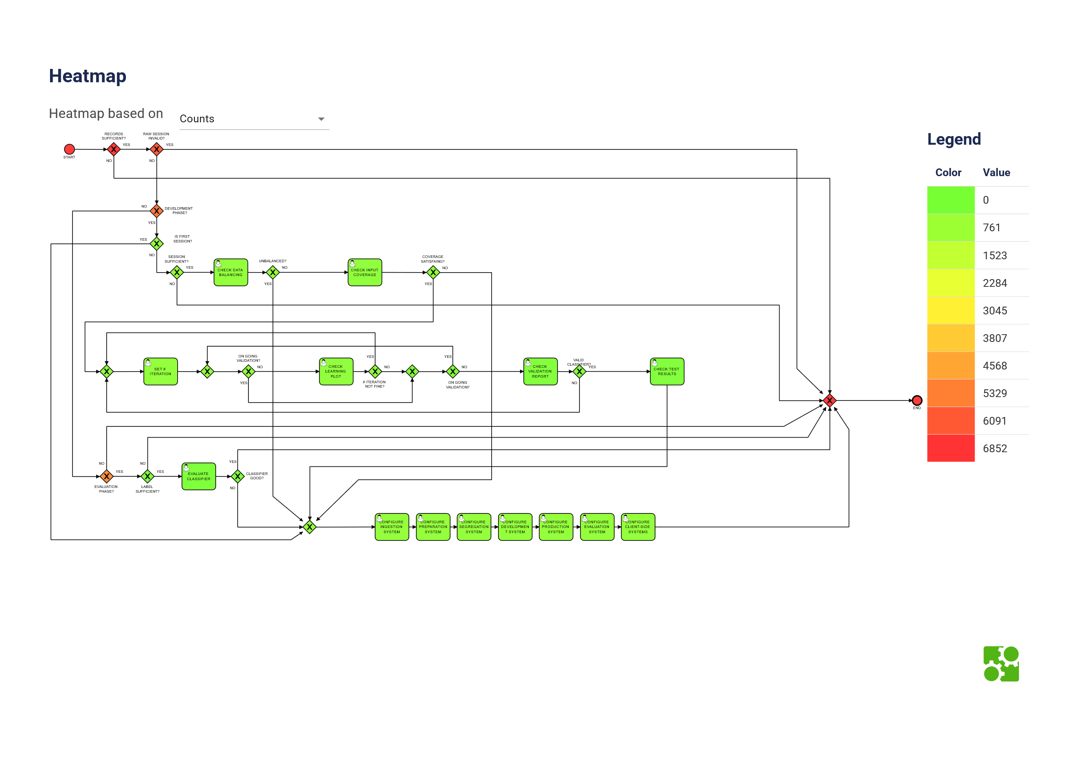TO-BE Heatmap of the counts of the parameters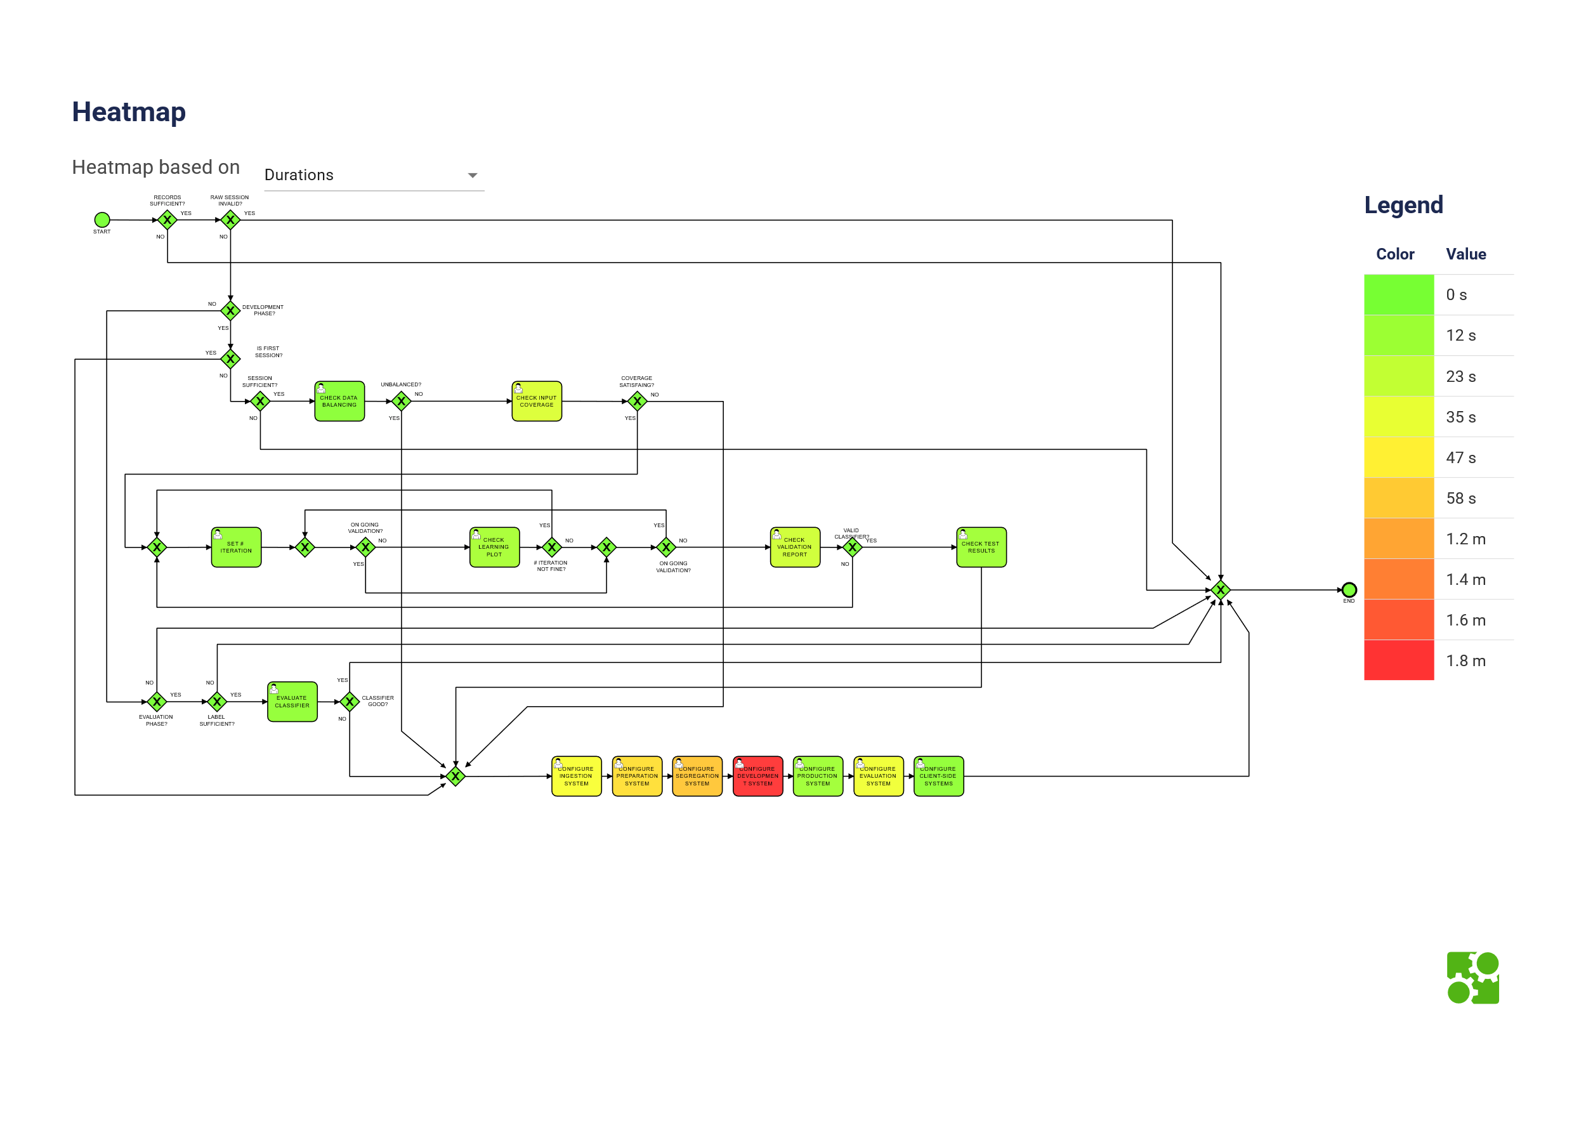

TO-BE Heatmap of the time spent in each passage [Durations]

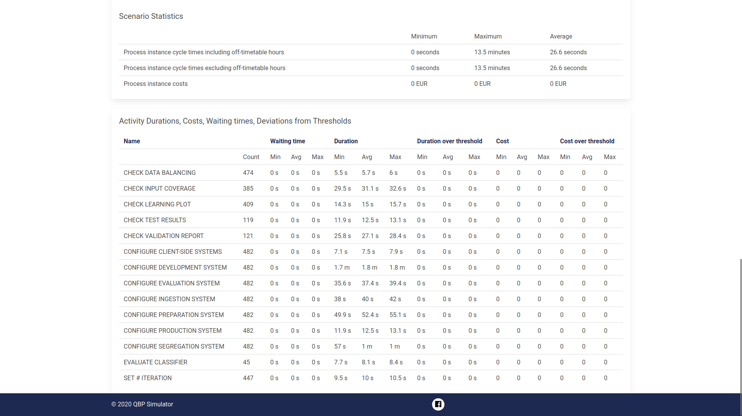

TO-BE Simulation Results

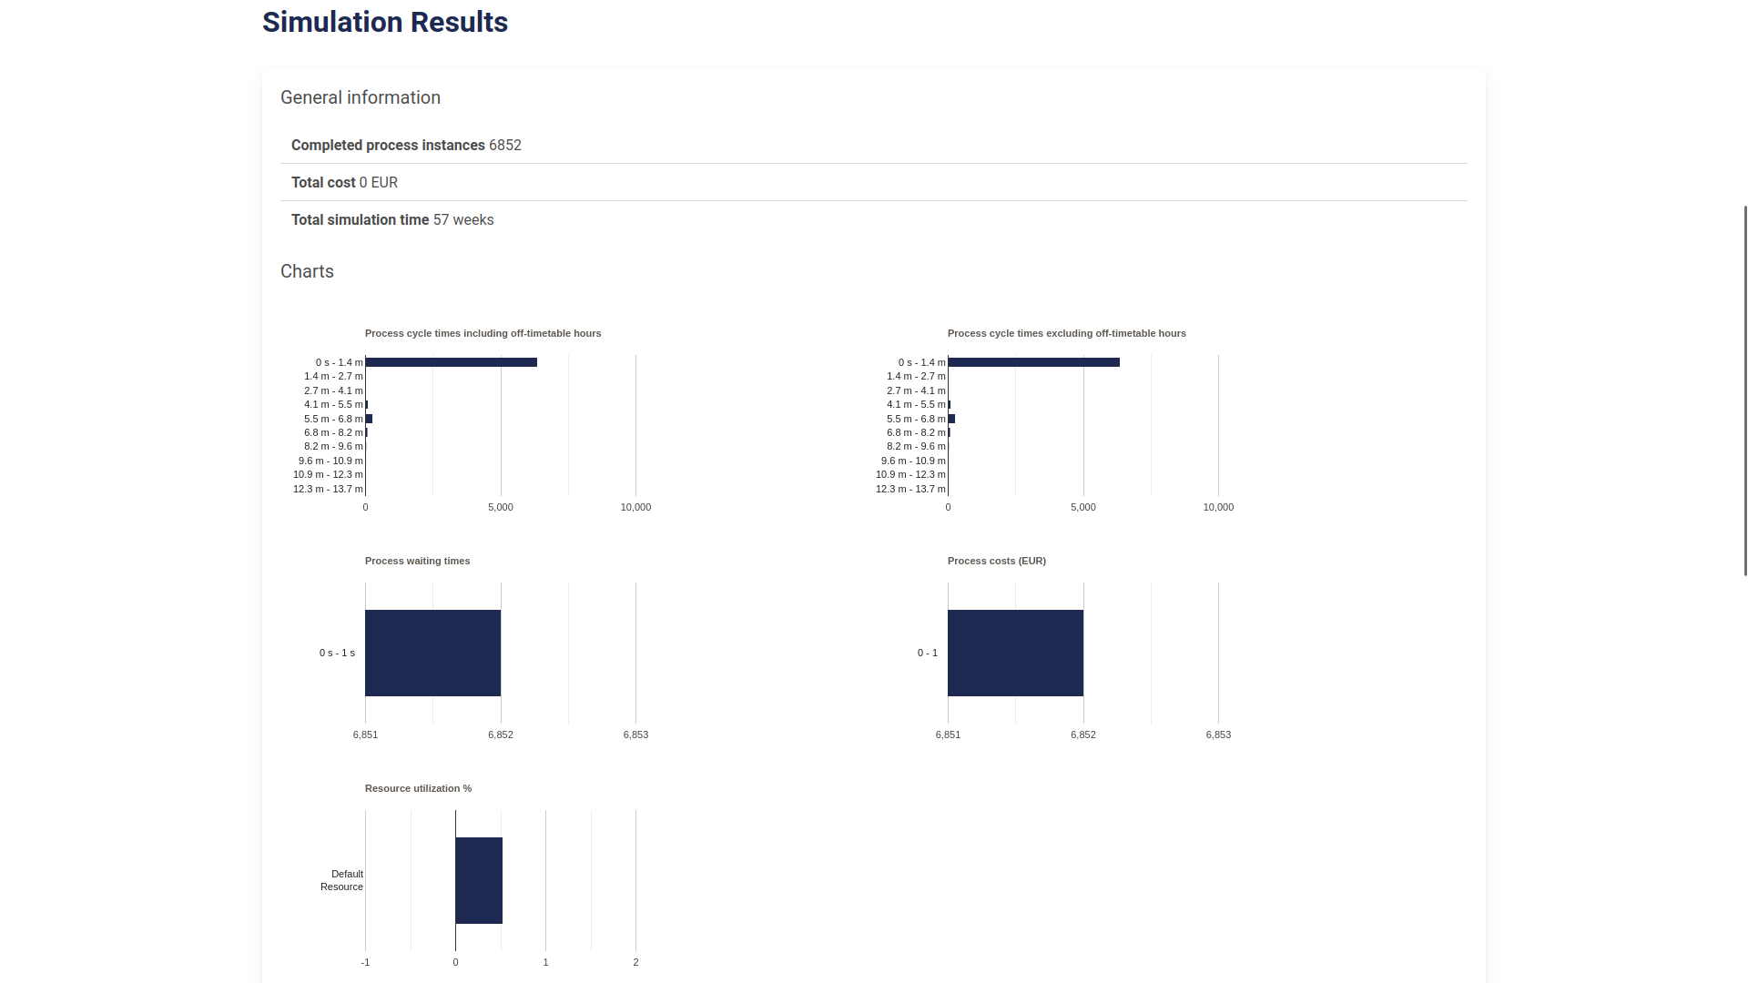

TO-BE Scenario Statistics

# Process mining

[*Ettore Ricci, Paolo Palumbo*]

We mined the logs generated by the simulation of the collapsed workflow.

We modified the simulation configuration to make the 100 tokens flow through every path of the workflow. The most important gateways that we changed are listed in the following table.

Gateways configuration

| **Gateway** | **Yes** | **No** |
| --- | --- | --- |
| RAW SESSION INVALID | 5% | 95% |
| RECORD SUFFICIENT | 95% | 5% |
| SESSION SUFFICIENT | 95% | 5% |
| IS FIRST SESSION | 20% | 80% |
| COVERAGE SATISFYING | 70% | 30% |
| DEVELOPMENT PHASE | 70% | 30% |

## 

## Transaction mining

[*Ettore Ricci, Paolo Palumbo*]

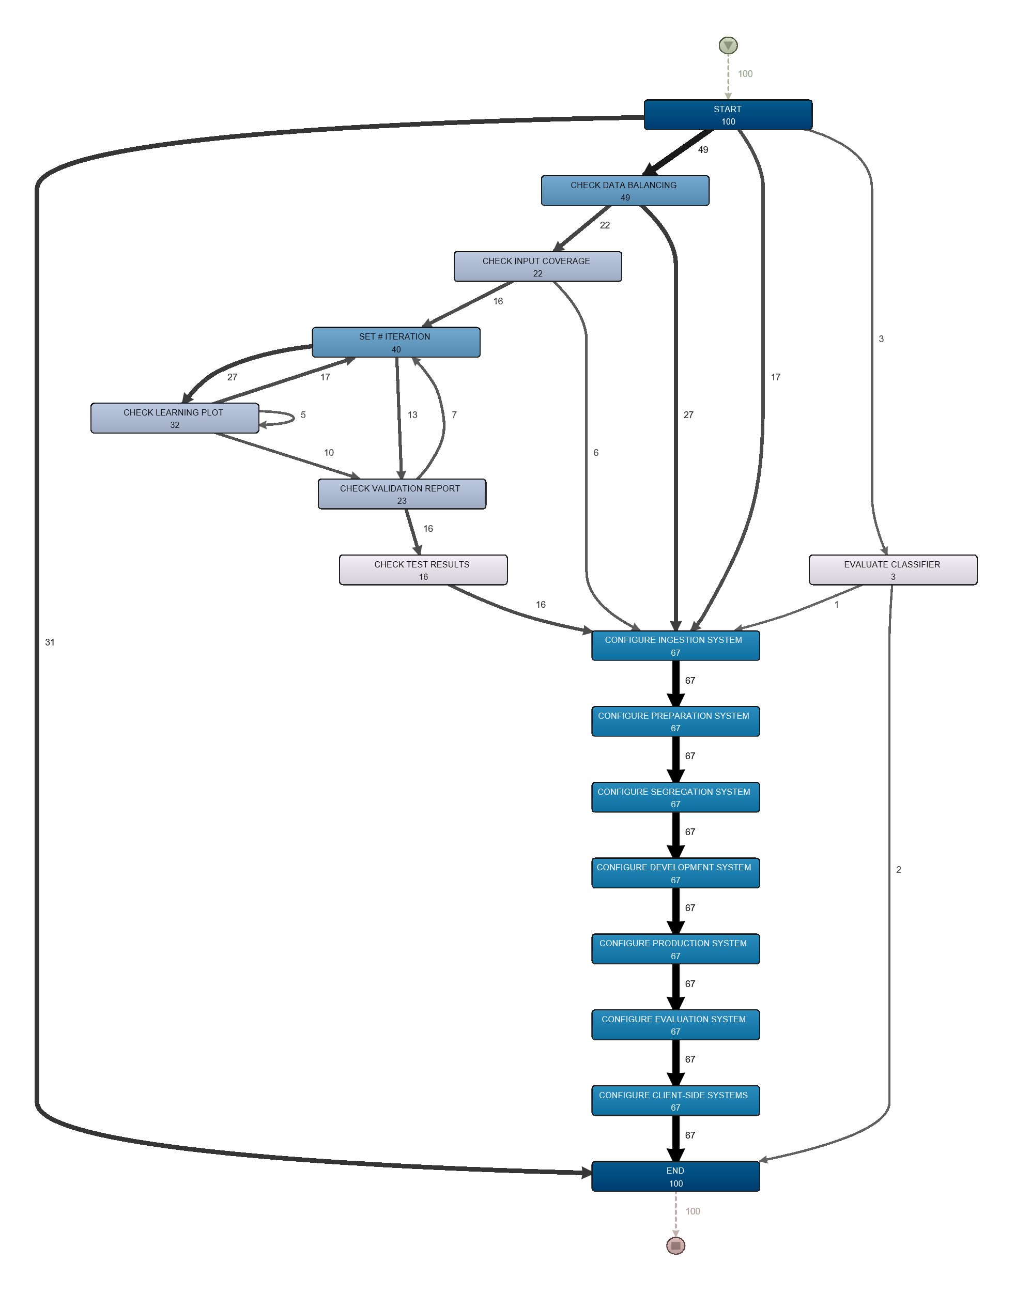

Disco analysis

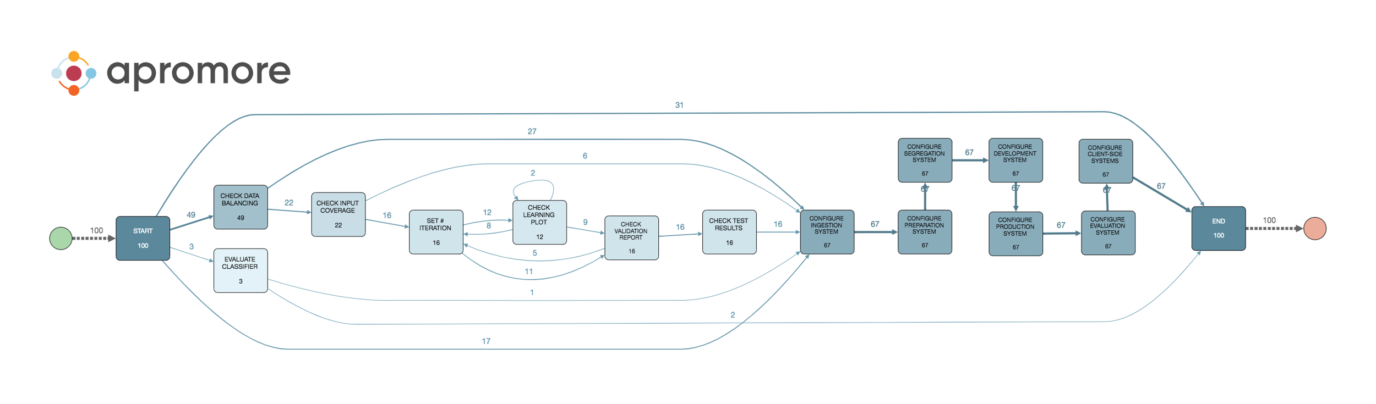

Apromore analysis

As we can see, the two transition maps mined from Disco and from Apromore are identical. The only difference stays in the frequencies because in Disco the frequencies are calculated as the total number of times a transition is executed, even on the same token; while in Apromore the frequencies are calculated as the number of individual tokens that execute a transition. This behavior can be changed with a setting in both tools.

## BPMN mining

[*Ettore Ricci, Paolo Palumbo*]

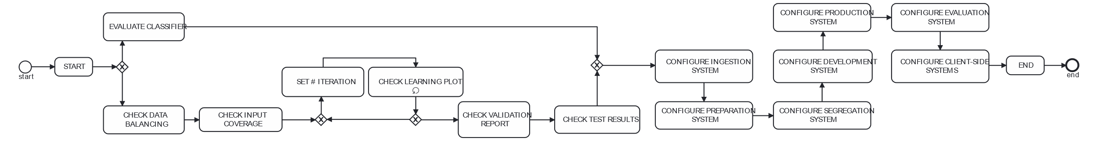

ProM mined BPMN model

We mined the logs using the "Heuristics Miner ProM6" mining algorithm.

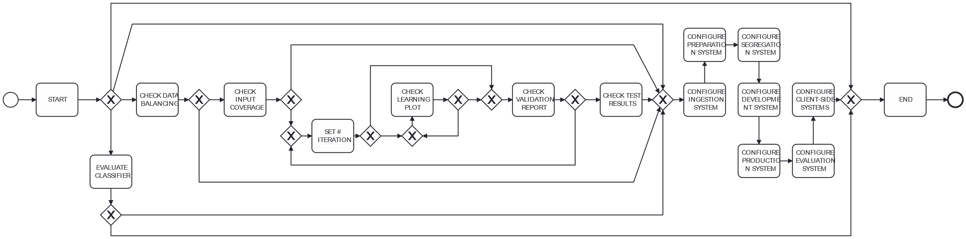

Apromore mined BPMN model

The BPMN model mined from Apromore is more detailed and covers more cases than the one mined from ProM. The key differences between the ProM model and the Apromore one are that the ProM model is missing the paths that skip the training and the configuration as well as one of the two paths that skip only the training. Furthermore, the training loop is much simpler in the ProM model, as it is missing every path that restarts the training after "CHECK VALIDATION REPORT".

## Conformance checking

[*Ettore Ricci, Paolo Palumbo*]

Comparison of the process mining tools

| **Tool** | **Fitness** | **Generalization** | **Precision** | **Simplicity** |
| --- | --- | --- | --- | --- |
| Apromore | 0.9928 | 0.9837 | 0.8199 | 62 |
| ProM | 0.7313 | 0.9902 | 0.8653 | 39 |

## Violations

[*Ettore Ricci, Paolo Palumbo*]

We modified the logs to introduce 3 violations in the workflow. The violations are the following:

1. Skipping the dataset creation ("CHECK DATA BALANCING" and "CHECK INPUT COVERAGE") using data from another user.
2. Skipping "SET # ITERATIONS" and "CHECK LEARNING PLOT" by using early stopping.
3. Skipping "CHECK DATA BALANCING" by using a resampling technique.

Each violation is introduced 3 times in the logs.

These 3 violations can be beneficial in terms of time and resources:

* The first violation can make the costs of the training significantly lower for the client, because using an old dataset allows us to skip the labeling of the new data and it usually is very expensive. Also the manual check of the dataset is skipped saving additional time and resources. It must be noted that this violation can be a problem for the privacy of the clients and also result in worse models if the data of the new user has different characteristics from the old one.
* The second violation can make the training faster, because we do not need anymore to check the learning plot manually and we can train each model only once instead of trying multiple times with different number of iterations. Also, the method previously used to determine the number of iterations was based on an heuristic and it can be prone to errors.
* The third violation can reduce the time and costs of the dataset creation, also making the training possible with unbalanced datasets.

Cases, violations and fitness on models generated by ProM and Apromore

| **CaseID** | **Violation** | **Fitness ProM** | **Fitness Apromore** |
| --- | --- | --- | --- |
| 10 | 1 | 0.91 | 0.87 |
| 20 | 1 | 0.85 | 0.84 |
| 47 | 1 | 0.86 | 0.86 |
| 53 | 2 | 0.91 | 0.93 |
| 63 | 2 | 0.84 | 0.82 |
| 88 | 2 | 0.91 | 0.93 |
| 6 | 3 | 0.91 | 0.93 |
| 72 | 3 | 0.91 | 0.85 |
| 81 | 3 | 0.94 | 0.87 |

|  |  |  |
| --- | --- | --- |
| image image image | image image image | image image image |

Screenshots of the logs while introducing the violations. The highlighted activities are the ones removed from the logs.

New fitness with violations included in the logs

| **Tool** | **Fitness** |
| --- | --- |
| Apromore | 0.9875 |
| ProM | 0.7256 |

|  |  |  |
| --- | --- | --- |
|  |  |  |



Violations in the Apromore model visualized with ProM

|  |  |  |
| --- | --- | --- |
|  |  |  |

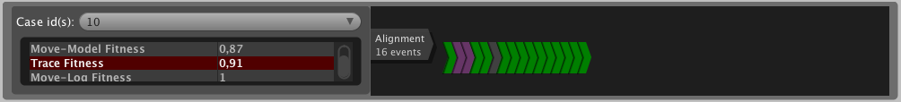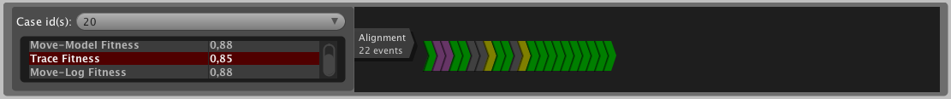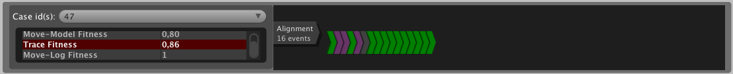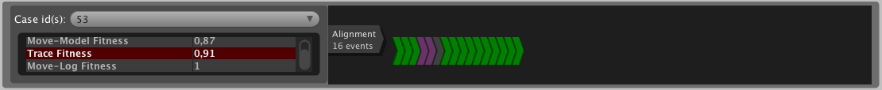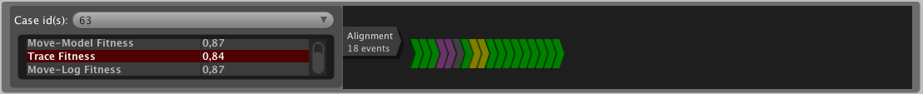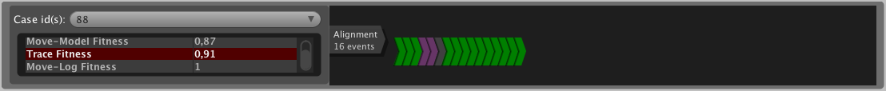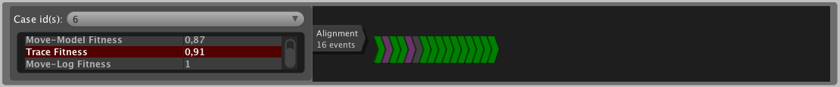

Violations in the ProM model visualized with ProM

### Transaction mining with violations

[*Ettore Ricci, Paolo Palumbo*]

Mining the logs with the violations included, we get these results:

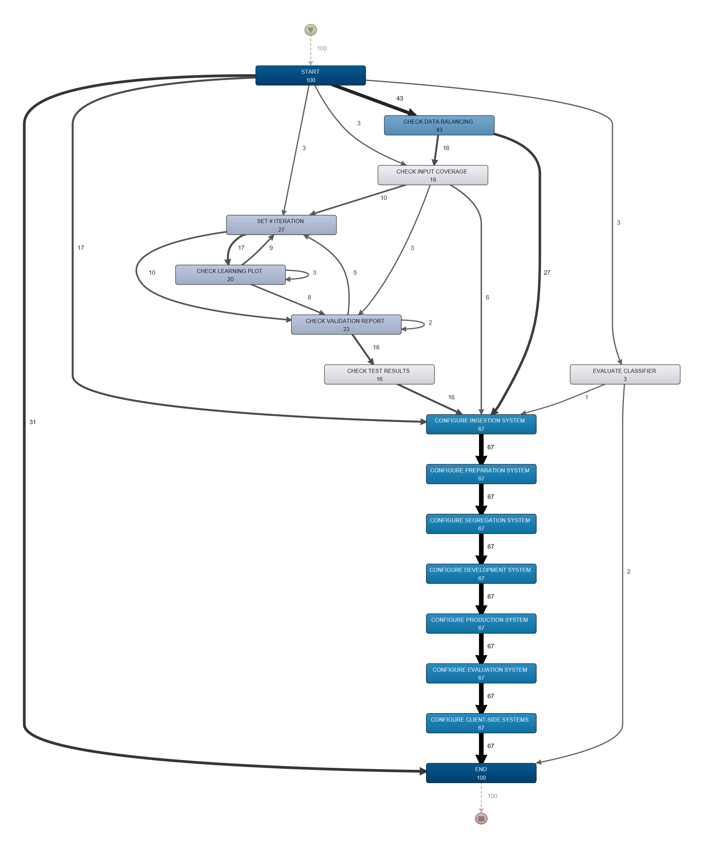

Disco transition map mined with violations

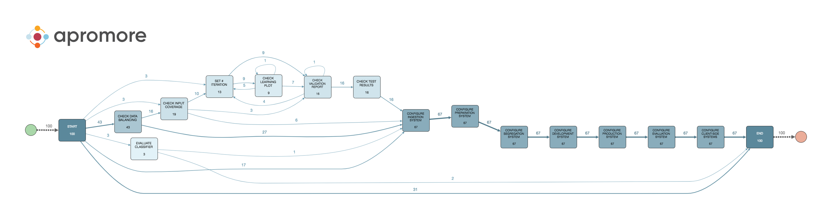

Apromore transition map mined with violations

### BPMN mining with violations

[*Ettore Ricci, Paolo Palumbo*]

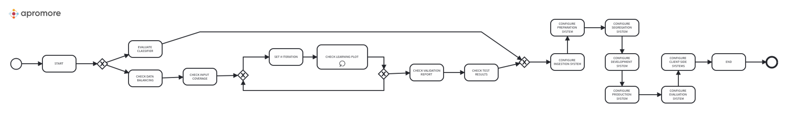

ProM mined BPMN model with violations

As we can see, the BPMN model mined from ProM with the violations included does not change at all from the one without the violations.

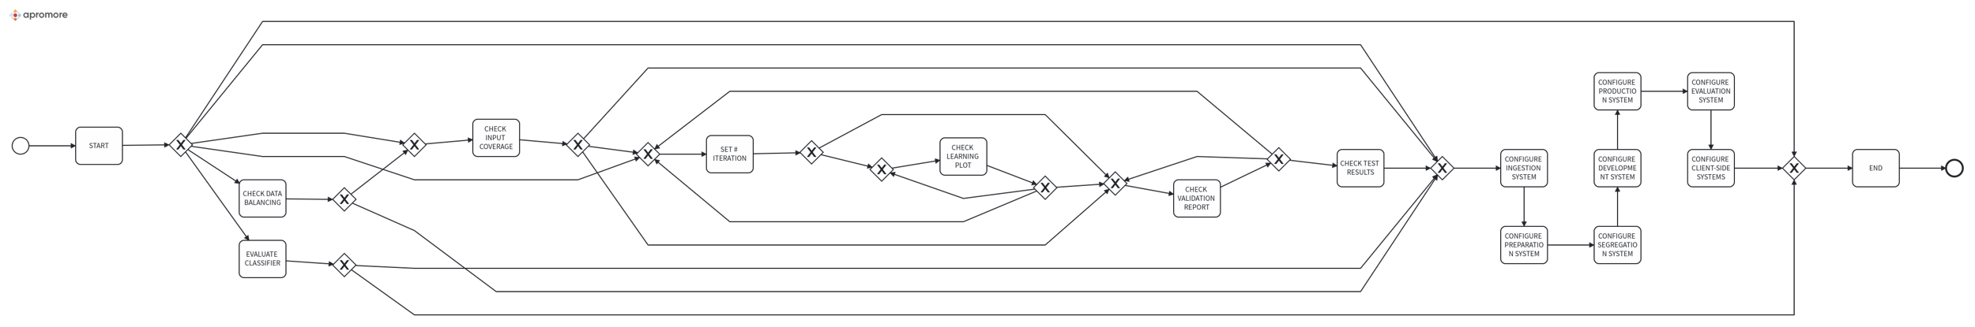

Apromore mined BPMN model with violations

On the other hand, the BPMN model mined from Apromore with the violations included changes according to the violations, ultimately having a higher fitness.

### Conformance checking with violations

[*Ettore Ricci, Paolo Palumbo*]

Comparison of the process mining tools with violations

| **Tool** | **Fitness** | **Generalization** | **Precision** | **Simplicity** |
| --- | --- | --- | --- | --- |
| Apromore | 1 | 0.9780 | 0.6742 | 69 |
| ProM | 0.7256 | 0.9909 | 0.8941 | 39 |

As expected, the fitness of the ProM mined model is the same as the one calculated with the same log, on the old model. Because the ProM model is much simpler than the Apromore one, its Generalization and Precision are higher while the Simplicity is lower. The Apromore model got more complex because of the violations, making its Generalization and Precision lower than the old model, also the Simplicity is a bit higher. The Apromore model, however, has a perfect fitness, because it is able to capture all the possible paths of the workflow, even with the violations.

Because the ProM model did not change, we won’t include its cases as they are the same as the ones from the old model.

|  |  |  |
| --- | --- | --- |
|  |  |  |



Violations in the new Apromore model visualized with ProM